



*Operating Lease Support System Development*

**For**



***Functional Specification***

***A.1 Marketing Module***

Revision 1.0

**Prepared by:**

**PT. Berlian Sistem Informasi**

KTB Annex Bld. 4th Floor, Jl. Jend. A. Yani. Pulomas,

Tel. +62 21 4786 7575 (Hunting) Fax. +62 21 4714964 [www.bsi.co.id](http://www.bsi.co.id)

Document Control

|  |  |
| --- | --- |
| **Author** | Deny Prasetia |
| **File Name** | TM14402A - DSF OLSS - FS A.1 Marketing Module Rev.1.0 |
| **Path** | N/A |
| **Create Date** | 9/10/2014 08:51:00 |
| **Last Edited** | 06/01/2015 15:18:00 |
| **Number of Pages** | 82 |

Revision History

|  |  |  |  |
| --- | --- | --- | --- |
| **Date** | **Revision** | **Description** | **Author** |
| 9-Oct-2014 | 0.0 | Initial creation | Deny Prasetia |
| 10-Oct-2014 | 0.1 | 1st Revision | Deny Prasetia |
| 20-Oct-2014 | 0.2 | 2nd Revision for correction | Satoshi Koibuchi |
| 21-Oct-2014 | 1.0 | 1st Baseline | Deny Prasetia |
|  |  |  |  |

Distribution List

|  |  |  |
| --- | --- | --- |
| **Name** | **Organization** | **Title** |
| Mr. Jin Nishimura | Dipo Star Finance, PT | DSF Project Director |
| Mr. Abdul Somad | Dipo Star Finance, PT | DSF Project Manager |
| Mr. Satoshi Koibuchi | Berlian Sistem Informasi, PT | BSI Project Director |
| Mr. Deny Prasetia | Berlian Sistem Informasi, PT | BSI Project Manager |

Document Approval

By signing this document I acknowledge I have read the document and give the Project Management Team approval to proceed.

|  |  |  |  |
| --- | --- | --- | --- |
| **Role** | **Name** | **Signature** | **Date** |
| DSF Project Director | Mr. Jin Nishimura |  |  |
| DSF Project Manager | Mr. Abdul Somad |  |  |
| BSI Project Director | Mr. Satoshi Koibuchi |  |  |
| BSI Project Manager | Mr. Deny Prasetia |  |  |

Table of Contents

Document Control 2

Revision History 2

Distribution List 2

Document Approval 2

1 Introduction 5

1.1 Purpose 5

1.2 Scope 5

1.3 Acronyms and abbreviations 7

1.4 References 7

2 Detail Specification 8

2.1 Calculation of Sales 8

**2.1.1** **Use case** 8

**2.1.2** **Operations and scenarios** 8

**2.1.3** **Status management and roles** 11

**2.1.4** **Sitemap design** 11

**2.1.5** **Screen design** 12

**2.1.5.1** **List of sales calculation** 12

**2.1.5.2** **Create new calculation of sales** 13

**2.1.5.3** **Update calculation of sales** 14

**2.1.5.4** **View detail calculation of sales** 15

**2.1.6** **Screen features** 16

**2.1.7** **Data structure** 16

2.2 Sales Quotation 18

**2.2.1** **Use case** 18

**2.2.2** **Operations and scenarios** 18

**2.2.3** **Status management and roles** 21

**2.2.4** **Sitemap design** 22

**2.2.5** **Screen design** 22

**2.2.5.1** **List of sales quotation** 22

**2.2.5.2** **Create new sales quotation** 23

**2.2.5.3** **Update sales quotation** 24

**2.2.5.4** **View detail sales quotation** 25

**2.2.5.5** **Preview and print sales quotation** 26

**2.2.6** **Screen features** 27

**2.2.7** **Data structure** 27

2.3 Calculation of Operating Lease 29

**2.3.1** **Use case** 29

**2.3.2** **Operations and scenarios** 29

**2.3.3** **Status management and roles** 33

**2.3.4** **Sitemap design** 34

**2.3.5** **Screen design** 34

**2.3.5.1** **List of operating lease calculation** 34

**2.3.5.2** **Create new calculation of operating lease** 35

**2.3.5.3** **Update calculation of operating lease** 40

**2.3.5.4** **View detail calculation of operating lease** 45

**2.3.5.5** **Preview and print operating lease calculation** 50

**2.3.5.6** **Preview and print operating lease proposal** 51

**2.3.6** **Screen features** 52

**2.3.7** **Data structure** 52

2.4 Operating Lease Quotation 57

**2.4.1** **Use case** 57

**2.4.2** **Operations and scenarios** 57

**2.4.3** **Status management and roles** 60

**2.4.4** **Sitemap design** 61

**2.4.5** **Screen design** 61

**2.4.5.1** **List of operating lease quotation** 61

**2.4.5.2** **Create new operating lease quotation** 62

**2.4.5.3** **Update operating lease quotation** 63

**2.4.5.4** **View detail operating lease quotation** 64

**2.4.5.5** **Preview and print operating lease quotation** 65

**2.4.6** **Screen features** 66

**2.4.7** **Data structure** 66

2.5 Agreement Information Inquiry 68

**2.5.1** **Use case** 68

**2.5.2** **Operations and scenarios** 68

**2.5.3** **Status management and roles** 71

**2.5.4** **Sitemap design** 72

**2.5.5** **Screen design** 72

**2.5.5.1** **List of agreement information inquiry** 72

**2.5.5.2** **Create new agreement** 74

**2.5.5.3** **Update agreement information** 75

**2.5.5.4** **View detail agreement** 76

**2.5.6** **Screen features** 77

**2.5.7** **Data structure** 77

3 Appendix 79

3.1 Use Case Terminology 79

3.2 Calculation Formula 80

1. Introduction
   1. Purpose

Functional specification is to explain some of the following:

1. Describe who uses your application or system,
2. Describe the order in which steps or events or on the scenario are performed,
3. Show user interface design, and
4. What kind of data that will be maintained by functions.
   1. Scope

Marketing module described about how to maintain data transaction on the marketing process which is utilized by functions in the system. On this module there’s no integration with another system (such as ACA and MFAPPL). This modules deal in the “to-be design” for developing the new system.

To keep the accuracy of entire design of the system we are using modeling approach for design and analysis. ***To define a model of functions we will determine use cases. In the use case, it can summarize who uses your application or system, and what they can do with it.***

Within a use case we can determine which use cases are supported by application. We can create use case diagram, activity diagram, use case scenario, data structure, and interface design.

A data structure can be specified what kind of information that will be required for the system. Data structure is represented database design of the system. A user interface design can imagine the user about the system as visual. User interface is designed based on prototypes which have been already created. And, based on these things, we will develop the system.

The following is functionality of marketing module:

* Calculation of Refinance

1. Create new calculation

To create a new calculation by filling out create calculation form. On this feature allowed saving calculation as draft or submitting a data to the next process.

1. Update calculation

Update calculation by changing some fields on the edit form.

1. Submit calculation

After calculation confirmed, calculation can be submitted to the next process.

1. Filter and sort calculation

On this feature the calculation record can be filtered and sorted based on columns on top of the list.

1. View detail calculation

To inspect a detail of calculation, this feature is able to display a calculation data. On this feature data is not able to edit.

1. Changes status of calculation

To update status of record by click the button.

* Refinance Quotation

1. Create new quotation

To create a new quotation by filling out create calculation form. On this feature allowed saving quotation as draft or submitting a data to the next process.

1. Update quotation

Update quotation by changing some fields on the edit form.

1. Submit quotation

After quotation confirmed, calculation can be submitted to the next process.

1. Filter and sort calculation

On this feature the quotation record can be filtered and sorted based on columns on top of the list.

1. View detail quotation

To inspect a detail of quotation, this feature is able to display a quotation data. On this feature data is not able to edit.

1. Changes status of quotation

To update status of record by click the button.

1. Preview and print the Refinance quotation

To preview and print the quotation result by click the button.

* Calculation of Operating Lease

1. Create new calculation

To create a new calculation by filling out create calculation form. On this feature allowed saving calculation as draft or submitting a data to the next process.

1. Update calculation

Update calculation by changing some fields on the edit form.

1. Submit calculation

After calculation confirmed, calculation can be submitted to the next process.

1. Filter and sort calculation

On this feature the calculation record can be filtered and sorted based on columns on top of the list.

1. View detail calculation

To inspect a detail of calculation, this feature is able to display a calculation data. On this feature data is not able to edit.

1. Changes status of calculation

To update status of record by click the button.

1. Preview and print the proposal and calculation

To preview and print the proposal and calculation result by click the button.

* Operating Lease Quotation

1. Create new quotation

To create a new quotation by filling out create calculation form. On this feature allowed saving quotation as draft or submitting a data to the next process.

1. Update quotation

Update quotation by changing some fields on the edit form.

1. Submit quotation

After quotation confirmed, calculation can be submitted to the next process.

1. Filter and sort calculation

On this feature the quotation record can be filtered and sorted based on columns on top of the list.

1. View detail quotation

To inspect a detail of quotation, this feature is able to display a quotation data. On this feature data is not able to edit.

1. Changes status of quotation

To update status of record by click the button.

1. Preview and print the operating lease quotation

To preview and print the operating lease quotation result by click the button.

* Agreement Information Inquiry

1. Create new agreement

To input data of agreement by fill out the form. This feature allows a user to save a data into database, after input on the agreement form.

1. Update agreement information

To update the agreement information by fill out the edit agreement form. This feature allows a user to changes a data on agreement information, and then saves into database.

1. Submit agreement information

After agreement confirmed, the data can be submitted to the next process.

1. Filter and sort agreement information

On this feature the agreement record can be filtered and sorted based on columns on top of the list.

1. View detail agreement information

To check and view the detail of agreement information, user can open details screen. On this features user only can viewing the data, (the data is not able to edit).

1. Changes status of quotation

After agreement was submitted, agreement can be confirm to validate or set to draft if the data still need to be update by user who initiate to create the agreement.

1. Preview and print the operating lease quotation

To preview and print the operating lease quotation result by click the button.

* 1. Acronyms and abbreviations
* ACA : Auto Credit Approval System
* MFAPPL : Multi Finance Application
  1. References

This functional scope refers “to be design” in the section A.1.Marketing Module.

1. Detail Specification
   1. Calculation of Refinance
      1. **Use case**

The figure below is summarizing who uses features of function, and what they can do with it.

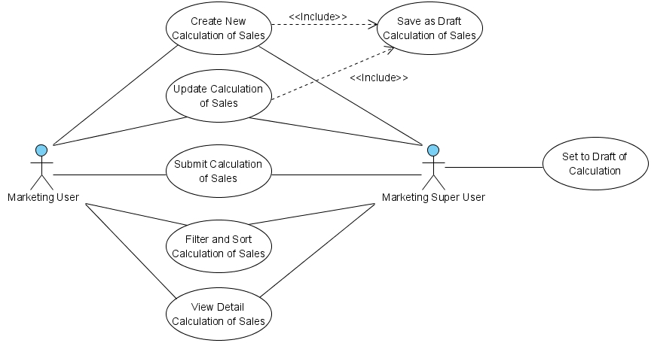

Figure 1 – Use case diagram of Calculation of Refinance

* + 1. **Operations and scenarios**

The figure below is describing operations or steps performed in a function interact with people (flow of work between actors and the system).

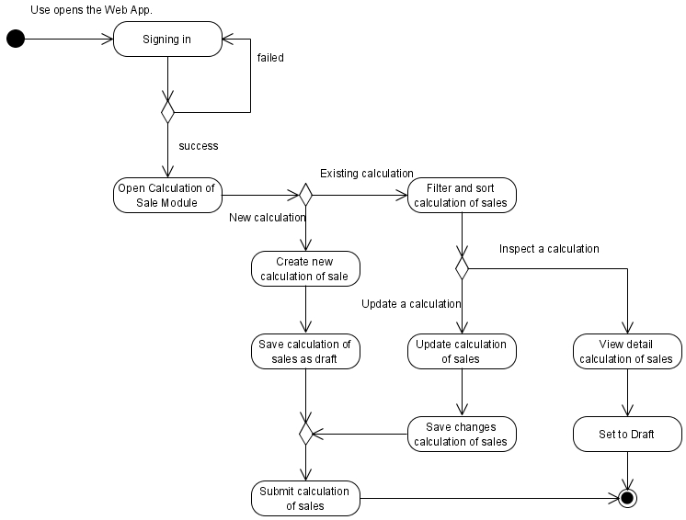

Figure 2 – Activity diagram of Calculation of Refinance

|  |  |  |  |
| --- | --- | --- | --- |
| **No.** | **Steps/ Operations** | **Actor/ People** | **Scenario** |
| 1 | Signing in | Marketing user, Marketing super user | * Actor fills out sign in form by inputting user name and password. * Actor clicks [sign in] button. System will check the account of user; if user account is already registered user will enter into the system. If doesn’t user can return the step. |
| 2. | Open calculation of Refinance module | Marketing user, Marketing super user | * After login, actor can open calculation of Refinance module on the menu of system. After that, screen of calculation of Refinance will open. * After screen opens, list of Refinance calculation will be shown and calculation data existing will be displayed. |
| 3. | Create new calculation | Marketing user, Marketing super user | * If calculation screen opens, actor can click [create] button to create new records of calculation and after that create calculation screen will open. * Upon create calculation screen, actor can fill out the fields. * To fill out lease contract information and product basic information, actor can click […] button at field of agreement number reff. Upon clicking […] button at look-up window will be shown. These windows have features to search and select the agreement. At least one agreement must be selected. * Profit Amount and Total Amount will be calculated automatically, after fill out the calculation fields. * The mandatory fields cannot be blank. |
| 4. | Save calculation as draft | Marketing user, Marketing super user | * After filling out the fields, actor can click [save as draft] button, if want to make a records as **draft**. * After that, system will proceed to store a data into database and will automatically check a validity of data (such as; data type, mandatory data, and data length) * If done, actor can click [Back] button to return to the list of Refinance calculation, then calculation data will be displayed. |
| 5 | Submit calculation record | Marketing user, Marketing super user | * Once data is saved and data has been confirmed, actor can submit the record by clicking [Submit] button. * After that system will set a calculation record as **submitted (or not draft)**. * If done, actor can click back button to return to the list of Refinance calculation. |
| 6. | Update calculation records | Marketing user, Marketing super user | * On the calculation of Refinance screen actor can click [Edit] button to update the calculation record by editing data on the edit calculation screen. * If there were calculation still draft, *marketing user* can click [edit] button on the right side of the records on the list of Refinance calculation. * If there were calculation record already submits and the status is **valid**, *marketing user* cannot click [edit] button to open edit calculation screen. * If edit calculation screen opens, actor can edit a record by inputting a data on each of the fields. * The mandatory fields cannot be blank. |
| 7. | Filter and sort calculation records | Marketing user, Marketing super user | * Actor can filter and sort the calculation record based on columns where displayed on the list of Refinance calculation. * To filter calculation records, actor can enter keywords into the filter fields. If matched data founds, the filtered result will be displayed on list. If doesn’t the list of Refinance calculation will be empty. * To sort calculation records, actor can click header of column on the list table. After that the records will be sorted by ascending or descending, alternately. * Upon select [record number filter] drop down list, actor can select a record number to display on the list of Refinance calculation. At least only one item can be selected. |
| 8. | View detail calculation record | Marketing user, Marketing super user | * On the calculation screen actor can open view detail calculation screen to inspect a data. * On the list of Refinance calculation screen, actor can click [view detail] button, after that system will display a screen of calculation detail. * On this screen, actor cannot do anything to edit of data. Only viewing calculation record. * There are 2 conditions when calculation detail screen opens:  1. If calculation status is still **draft** or already **valid**, [validate] button and [set to draft] button will be disappeared. 2. If calculation status was already **submitted**, [validate] button and [set to draft] button will be shown.  * If done, actor can click back button to return to the list. |
| 9 | Set to draft of calculation | Marketing super user | * To do this process, actor should open calculation detail screen by clicking [view detail] button in the list of Refinance calculation screen. Once calculation detail screen opens, actor can change the status of calculation by clicking [set to draft] button. If calculation still need to revise and status still not valid yet, actor can change the calculation status from **submitted** to **draft**. * After that, system will proceed automatically to change the status, and actor can click [Back] button to return to the list of Refinance calculation. |

* + 1. **Status management and roles**

The figure below is describing a role matrix (including relation with Status) of actor that already identified in a function.

|  |  |  |  |  |  |  |
| --- | --- | --- | --- | --- | --- | --- |
| **Role of Actor** | **Filter and sort** | **Save as draft** | **Save changes**  **(draft)** | **Save changes**  **(submitted)** | **Submit** | **Validate** |
| Marketing super user | Yes | Yes | Yes | Yes | Yes | Yes |
| Marketing user | Yes | Yes | Yes | No | Yes | No |

The figure below is describing transition of Status that performed when people interact in a function. In this features, validation (validate and invalidate) process triggered on the Refinance quotation module. If the quotation already validate, so the status of calculation will be valid too, and vice versa.

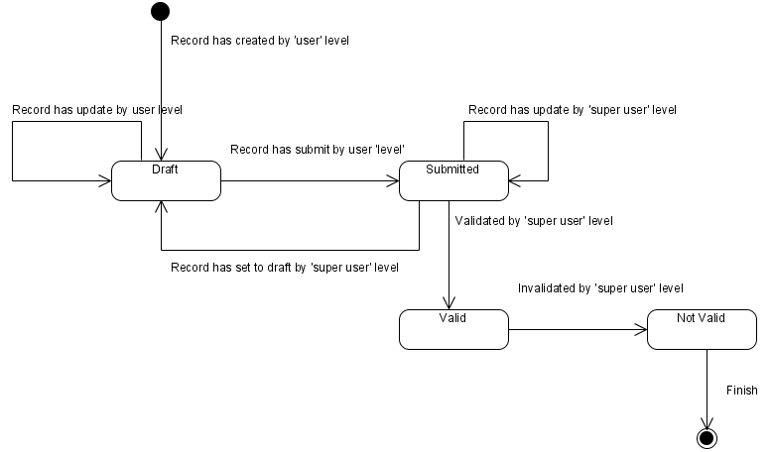

Figure 3 – Status diagram of Calculation of Refinance

* + 1. **Sitemap design**

Describe a web page that lists the pages on a web site to users. Usually sitemap organized in hierarchical style.

Figure 4 – Sitemap design of Calculation of Refinance

* + 1. **Screen design**
       1. **List of Refinance calculation**

This screen is designed to display a calculation of Refinance list. On this list actor can filter and sort a calculation records. And also, actor can open another screen to create new calculation record, update calculation record, and view detail of calculation record.

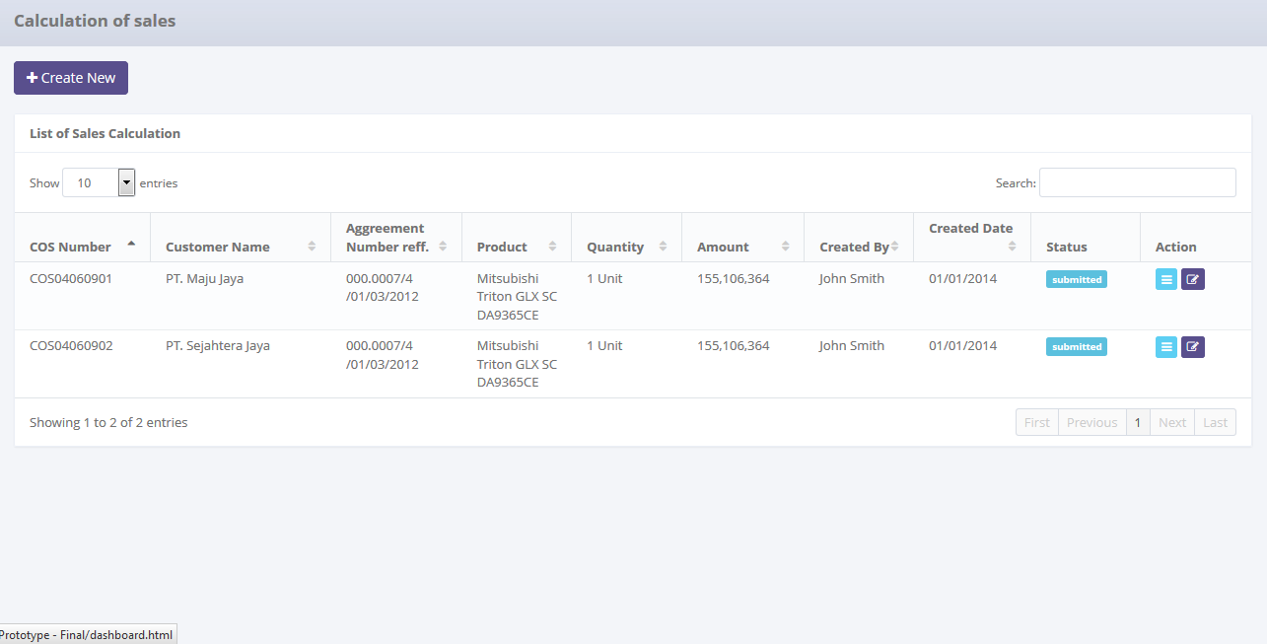

To create new calculation

To open edit or view detail calculation

Displaying calculation list

To filter a number of record filter button

To filter calculation record

To open paging of records

Data paging information

Image 1 – List of Refinance Calculation Screen

* + - 1. **Create new calculation of Refinance**

This screen is designed to create new calculation of Refinance record. After filling out necessary data on the screen, actor can store a data into the system by clicking the action button.

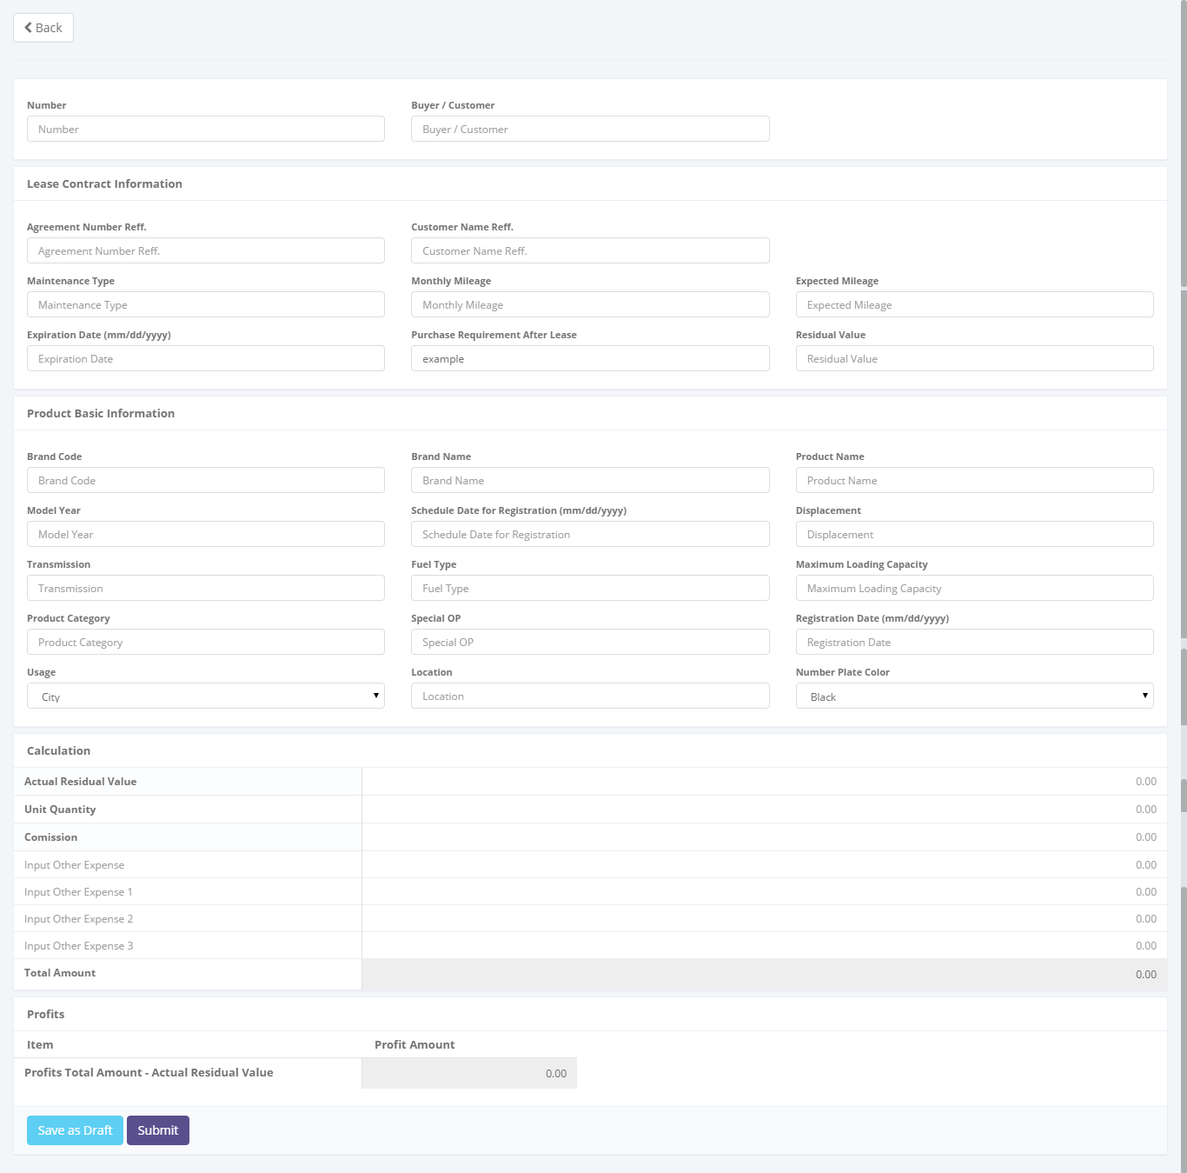

To save or submit calculation data

Return back to list of sales calculation

To entry a calculation data

Image 2 – Screen of Create New Calculation of Refinance

* + - 1. **Update calculation of Refinance**

This screen is designed to update calculation of Refinance. After changing some data on the screen, actor can store a data into the system by clicking the action button.

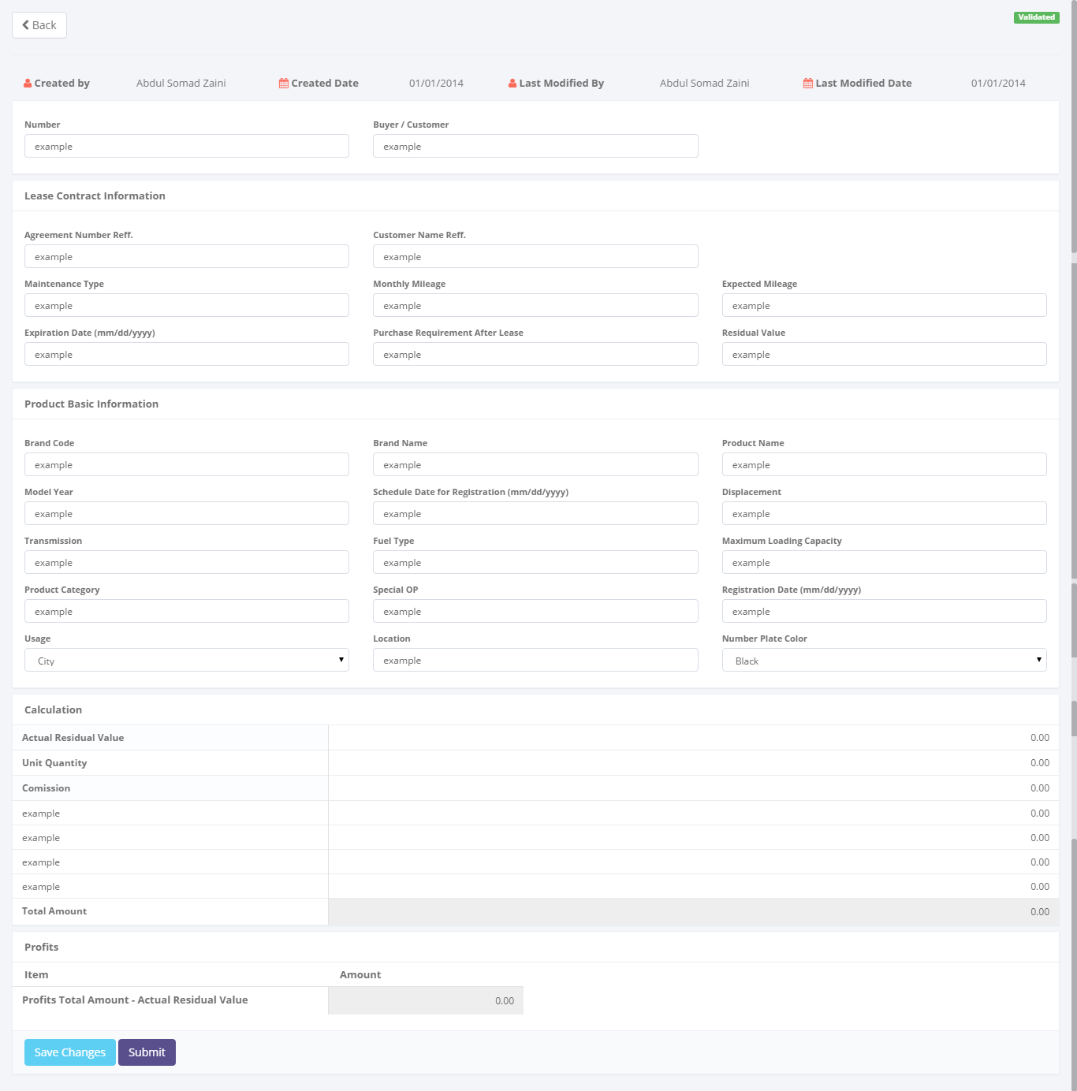

To save or submit of data

Entry data form

Return back to list of sales calculation

Image 3 – Screen of Update Calculation of Refinance

* + - 1. **View detail calculation of Refinance**

This screen is designed to view detail a calculation of Refinance. On this screen actor can change status of a Refinance calculation by clicking action button.

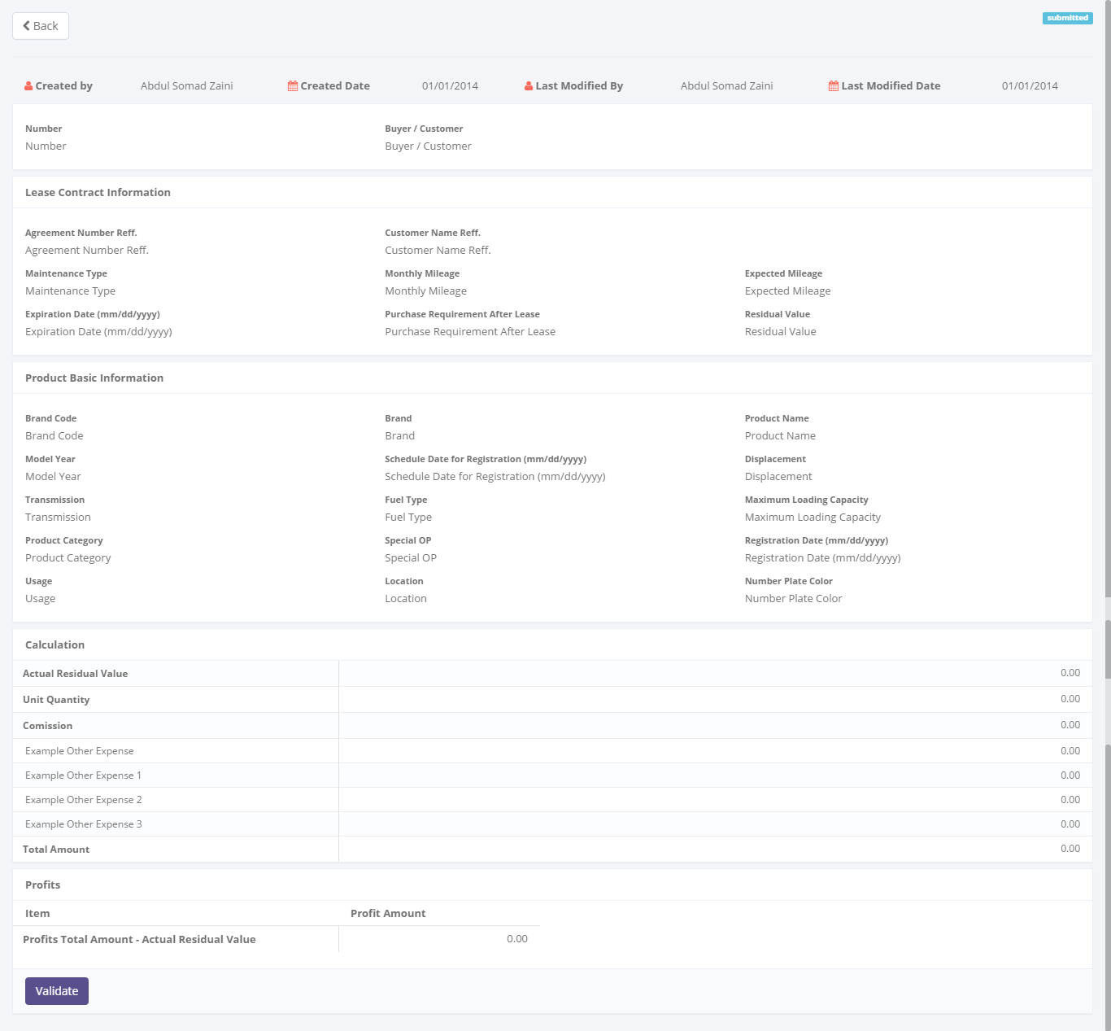

To changes a status of calculation record

Detail calculation

Return back to list of sales calculation

Status of calculation

Image 4 – Screen of View Detail Calculation of Refinance

* + 1. **Screen features**

|  |  |
| --- | --- |
| **Features** | **Description** |
| [Filter and sort] | To perform data filtering and data sorting of calculation records. |
| [Create new] | To create new calculations by entering data on create new calculation form. |
| [Save as draft] or [Set to draft] | To save a calculation as a draft. |
| [Submit] | To submit a calculation record as a final. |
| [Save changes] | To update changes when editing calculation record. |
| [View detail] | To inspect a detail calculation records by opening a calculation detail form. |
| [Edit] | To update of calculation record. |

* + 1. **Data structure**

|  |  |  |  |  |
| --- | --- | --- | --- | --- |
| **Field** | **Data Type** | **Data Length** | **Format** | **Mandatory** |
| **Calculation Identity** | | | | |
| Calculation of Refinance Number | Text | 50 | N/A | *Yes* |
| Buyer/ Customer Name | Text | 200 | N/A | *Yes* |
| **Lease Contract Information** | | | | |
| Agreement Number Reff. | Text | 50 | N/A | *Yes* |
| Customer Name Reff. | Text | 200 | N/A | *Yes* |
| Maintenance Type | Text | 100 | N/A | *No* |
| Monthly Mileage | Number | N/A | ###,###,###.## | *No* |
| Expected Mileage | Number | N/A | ###,###,###.## | *No* |
| Expiration Date | Date | N/A | mm-dd-yyyy | *No* |
| Purchase Requirement After Refinance | Text | 200 | N/A | *No* |
| Residual Value | Decimal | 18,3 | ###,###,###.## | *No* |
| **Product Basic Information** | | | | |
| Product Registration Code | Text | 50 | N/A | *Yes* |
| Product Type | Text | 100 | N/A | *Yes* |
| Product Category | Text | 50 | N/A | *Yes* |
| Product Brand Code | Text | 50 | N/A | *Yes* |
| Product Brand Name | Text | 100 | N/A | *Yes* |
| Product Model Code | Text | 100 | N/A | *Yes* |
| Product Model Name | Text | 100 | N/A | *Yes* |
| Product Model Type | Text | 100 | N/A | *Yes* |
| Product Model Year | Date | N/A | mm-yyyy | *Yes* |
| Transmission | Text | 100 | N/A | *Yes* |
| Fuel Type | Text | 100 | N/A | *Yes* |
| Displacement (cc) | Text | 100 | N/A | *Yes* |
| Maximum Loading Capacity | Number | 50 | N/A | *No* |
| Product Category | Text | 100 | N/A | *No* |
| Number Plate Color | Text | 100 | N/A | *No* |
| Usage | Text | 100 | N/A | *No* |
| Location | Text | 100 | N/A | *No* |
| Schedule Date for Registration | Decimal | 18,3 | mm-dd-yyyy | *No* |
| Registration Date | Date | N/A | mm-dd-yyyy | *No* |
| **Calculation** | | | | |
| Actual Residual Value | Decimal | 18,3 | ###,###,###.## | *Yes* |
| Unit Quantity | Decimal | 18,3 | ###,###,###.## | *Yes* |
| Commission | Decimal | 18,3 | ###,###,###.## | *No* |
| Other Expense 1 | Decimal | N/A | ###,###,###.## | *No* |
| Other Expense 2 | Decimal | 18,3 | ###,###,###.## | *No* |
| Other Expense 3 | Decimal | 18,3 | ###,###,###.## | *No* |
| Total Amount | Decimal | 18,3 | ###,###,###.## | *Yes* |
| Profit Amount | Decimal | 18,3 | ###,###,###.## | *Yes* |
| **Audit Rail** | | | | |
| Create By | Text | 100 | N/A | *Yes* |
| Create Date | Date time | N/A | mm-dd-yyyy:hh-mm-ss | *No* |
| Last Modified By | Text | 100 | N/A | *Yes* |
| Last Modified | Date time | N/A | mm-dd-yyyy:hh-mm-ss | *No* |
| **Status Management** | | | | |
| Is Deleted | Yes/No | N/A | N/A | *Yes* |
| Is Draft | Yes/No | N/A | N/A | *Yes* |
| Is Submitted | Yes/No | N/A | N/A | *Yes* |
| Is Valid | Yes/No | N/A | N/A | *Yes* |

* 1. Refinance Quotation
     1. **Use case**

The figure below is summarizing who uses features of function, and what they can do with it.

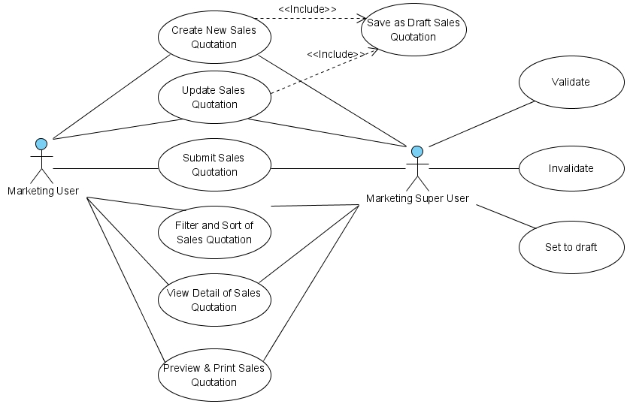

Figure 5 – Use case diagram of Refinance Quotation

* + 1. **Operations and scenarios**

The figure below is describing operations or steps performed in a function interact with people (flow of work between actors and the system).

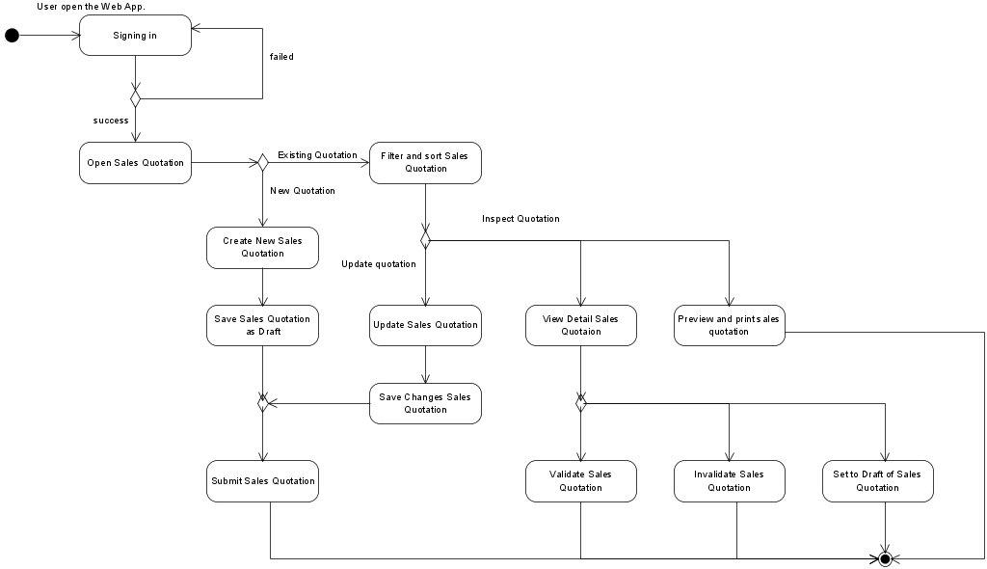

Figure 6 – Activity diagram of Refinance Quotation

|  |  |  |  |
| --- | --- | --- | --- |
| **No.** | **Steps/ Operations** | **Actor/ People** | **Scenario** |
| 1 | Signing in | Marketing user, Marketing super user | * Actor fills out sign in form by inputting user name and password. * Actor clicks [sign in] button. System will check the account of user; if user account is already registered user will enter into the system. If doesn’t user can return the step. |
| 2. | Open calculation of Refinance module | Marketing user, Marketing super user | * After login, actor can open Refinance quotation module on the menu of system. After that, the Refinance quotation screen will open. * After screen opens, Refinance quotation list will be shown and existing data will be displayed. |
| 3. | Create new Refinance quotation | Marketing user, Marketing super user | * If list of Refinance quotation screen opens, actor can click [create] button to create new quotation and after that create Refinance quotation screen will open. On this screen actor can specify the calculation records as basis to create the Refinance quotation. * To specify the calculation records, click […] button at calculation number, after that look-up window will be shown. These windows have features to search and select the calculation. At least one calculation must be selected. Once it done, actor can fill out other information on each field. * The mandatory fields cannot be blank. |
| 4. | Save Refinance quotation as draft | Marketing user, Marketing super user | * After filling out the fields, actor can click [save as draft] button, if want to make a records as **draft**. * After that, system will proceed to store a data into database and will automatically check a validity of data (such as; data type, mandatory data, and data length) * If done, actor can click [Back] button to return to the list of Refinance calculation, then Refinance quotation data will be displayed. |
| 5 | Submit Refinance quotation record | Marketing user, Marketing super user | * Once data is saved and data has been confirmed, actor can submit the record by click [Submit] button. * After that system will set a Refinance quotation record as **submitted (or not draft)**. * If done, actor can click back button to return to the list of Refinance quotation. |
| 6. | Update Refinance quotation records | Marketing user, Marketing super user | * On the list of Refinance quotation screen actor can click [Edit] button to update the record by editing data on the edit screen. * If the quotations still **draft**, *marketing user* can click [edit] button on the right side of the records on list of Refinance quotation screen. * If the quotation records already **submit** and the status is **valid**, *marketing user* cannot click [edit] button to open edit Refinance quotation screen. * If edit screen opens, actor can edit a record by inputting a data on each of the fields. * The mandatory fields cannot be blank. |
| 7. | Filter and sort Refinance quotation records | Marketing user, Marketing super user | * Actor can filter and sort the record based on columns where displayed on the list. * To filter the records, actor can enter keywords into the filter fields. If matched data founds, the result will be displayed on the list. If doesn’t, the list will be empty. * To sort the records, actor can click header of column on the list table. After that the records will be sorted by ascending or descending, alternately. * Upon select [record number filter] drop down list, actor can filter a record number to display on the list. At least only one item can be selected. |
| 8. | View detail Refinance quotation record | Marketing user, Marketing super user | * On the list of Refinance quotation screen actor can view detail a Refinance quotation on the view detail screen. * To open view detail screen, actor can click [view detail] button, after that system will display a detail of Refinance quotation. On this screen, actor cannot do anything to edit of data. Only viewing the record. * There are 2 conditions when view detail screen opens:  1. If the Refinance quotation status is still **draft** or already **valid**, [validate] button and [set to draft] button will be disappeared. 2. If Refinance quotation status was already **submitted,** [validate] button and [set to draft] button will be shown.  * If done, actor can click [Back] button to return to the list. |
| 9 | Validate Refinance quotation | Marketing super user | * To do this process, actor should open view detail screen by clicking [view detail] button on the list. Once view detail screen opens, actor can change the status by clicking [validate] button. If Refinance quotation is already confirmed. After status changes to **valid**, actor cannot rollback the status to **submitted** or **draft**. * After that, system will proceed automatically to change the status, and actor can click [Back] button to return to the list. |
| 10 | Invalidate Refinance quotation | Marketing super user | * For the worst case, if Refinance quotation were made inoperative/ not applicable, actor can change the status from **valid** to **not valid**. * To do this process, actor should open view detail screen by clicking [view detail] button on the list. Once view detail screen opens, actor can change the status by clicking [Invalidate] button. * After that, system will proceed automatically to change the status, and actor can click [Back] button to return to the list. |
| 11 | Set to Draft Refinance quotation | Marketing super user | * To utilize this feature; If Refinance quotation still need to be revised and status still not valid yet, actor can change the status from **submitted** to **draft**. * To do this process, actor should open view detail screen by clicking [view detail] button on the list. Once view detail screen opens, actor can change the status by clicking [validate] button or [set to draft] button (depending by status that needs to change). * After that, system will proceed automatically to change the status, and actor can click [Back] button to return to the list. |
| 12 | Preview and print Refinance quotation | Marketing user, Marketing super user | * To do this process, actor can select the quotation record by clicking [Print preview] button, and after that the preview screen will be opened. * Once preview screen opens, actor can click [Print] button to print the report. * If done, actor can click [Back] button to return to the list. |

* + 1. **Status management and roles**

The figure below is describing a role matrix (including relation with Status) of actor that already identified in a function.

|  |  |  |  |  |  |  |  |
| --- | --- | --- | --- | --- | --- | --- | --- |
| **Role of Actor** | **Filter and sort** | **Save as draft** | **Save changes**  **(draft)** | **Save changes**  **(submitted)** | **Submit** | **Validate** | **Preview & Print** |
| Marketing super user | Yes | Yes | Yes | Yes | Yes | Yes | Yes |
| Marketing user | Yes | Yes | Yes | No | Yes | No | Yes |

The figure below is describing transition of Status that performed when people interact in a function. In this features, validation (validate and invalidate) process triggered on the operating lease quotation module. If the quotation already validate, so the status of Refinance quotation will be valid too, and vice versa.



Figure 7 – Status diagram of Calculation of Refinance

* + 1. **Sitemap design**

Describe a web page that lists the pages on a web site to actors. Usually sitemap organized in hierarchical style.

Figure 8 – Sitemap design of Refinance Quotation

* + 1. **Screen design**
       1. **List of Refinance quotation**

This screen is designed to display a list of Refinance quotation. On this list actor can filter and sort a calculation records. And also, actor can open another screen to create new quotation record, update quotation record, and view detail quotation record.

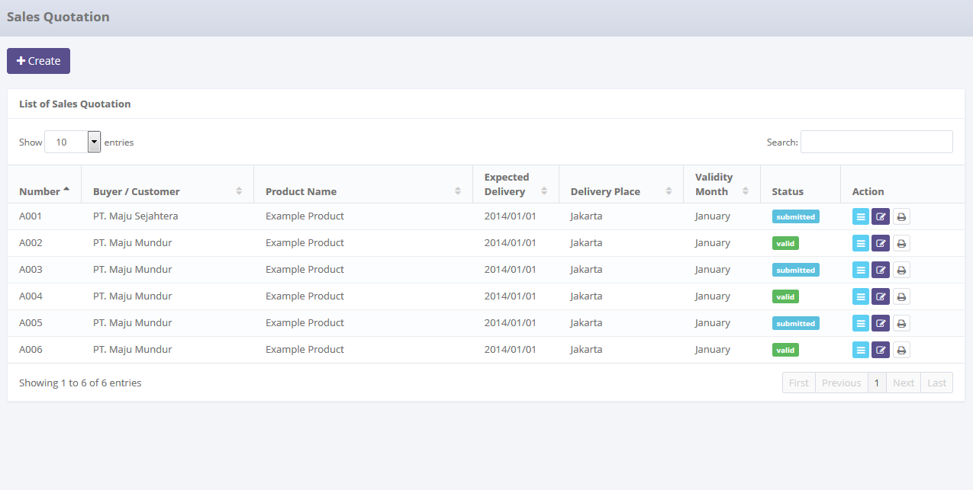

To open paging the records

Data paging information

To filter a number of record filter button

To filter sales quotation record

Displaying list

To create new sales quotation

To open edit or view detail sales quotation

Image 5 – List of Refinance Quotation Screen

* + - 1. **Create new Refinance quotation**

This screen is designed to create new Refinance quotation record. After filling out necessary data on the screen, actor can store a data into the system by clicking the action button.

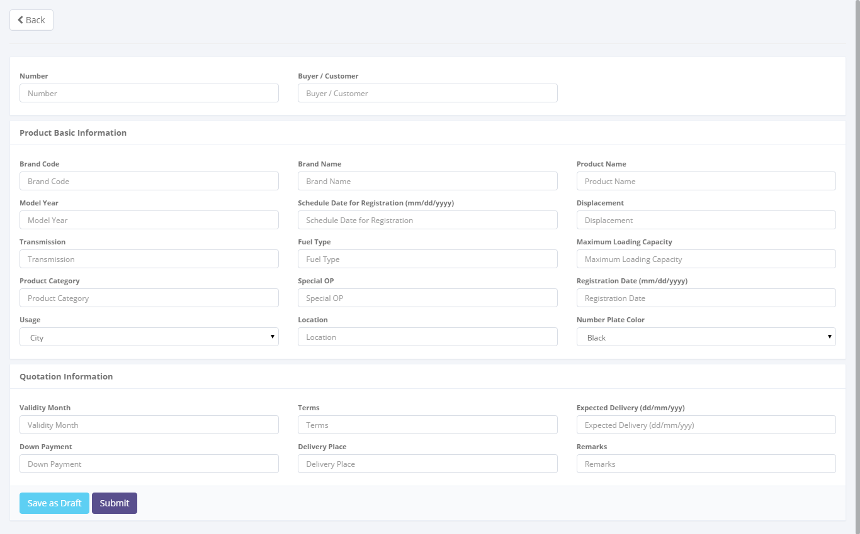

To save or submit calculation data

To entry a calculation data

Return back to list of sales calculation

Image 6 – Screen of Create New Refinance Quotation

* + - 1. **Update Refinance quotation**

This screen is designed to update Refinance quotation. After changes some data on the screen, actor can store a data into the system by click the action button.

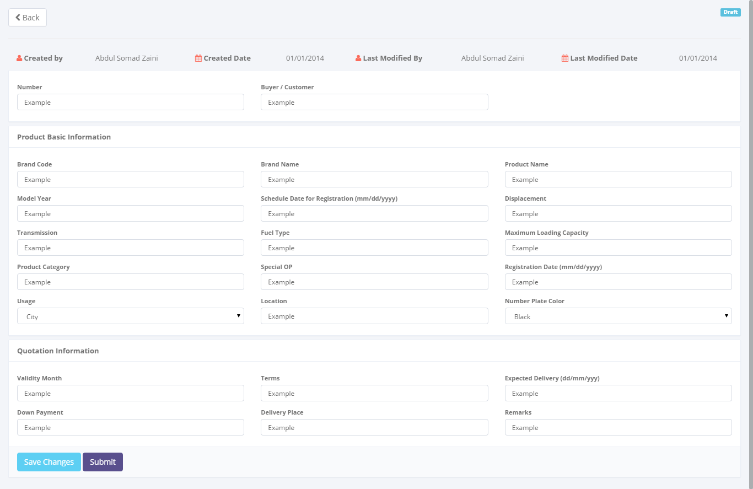

Entry data form

Status of sales quotation

To save or submit of data

Return back to list of sales quotation

Image 7 – Screen of Update Refinance Quotation

* + - 1. **View detail Refinance quotation**

This screen is designed to view detail Refinance quotation. On this screen actor can change status of a calculation of Refinance by clicking action button.

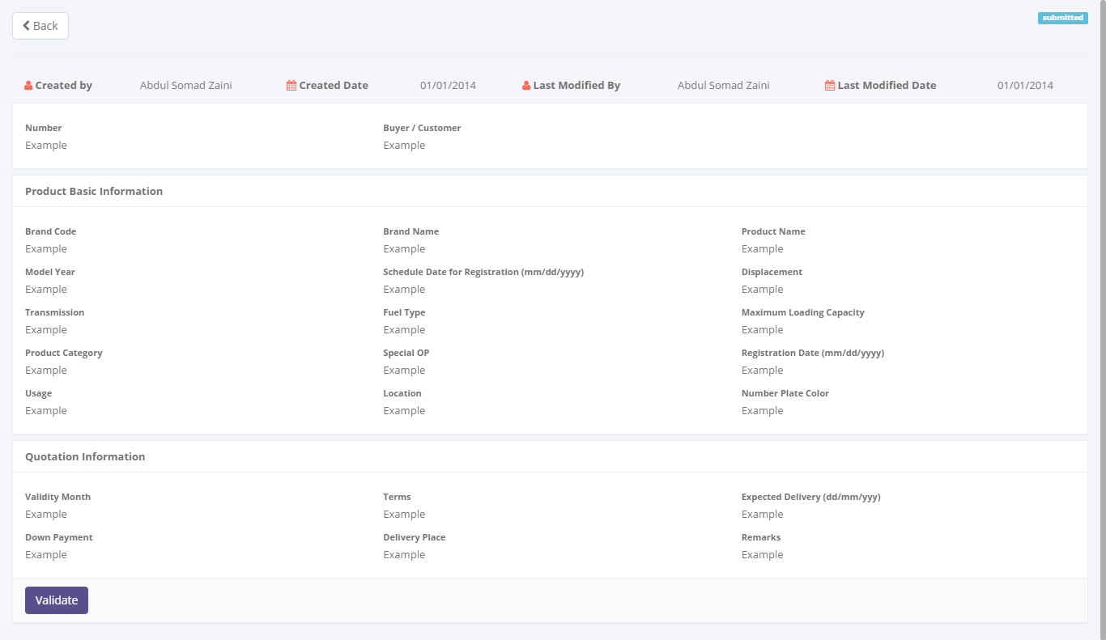

To changes a status of sales quotation record

Status of sales quotation

Detail sales quotation

Return back to list of sales quotation

Image 8 – Screen of View Detail Refinance Quotation

* + - 1. **Preview and print Refinance quotation**

This screen is designed to view detail Refinance quotation. On this screen actor can change status of a calculation of Refinance by clicking action button.

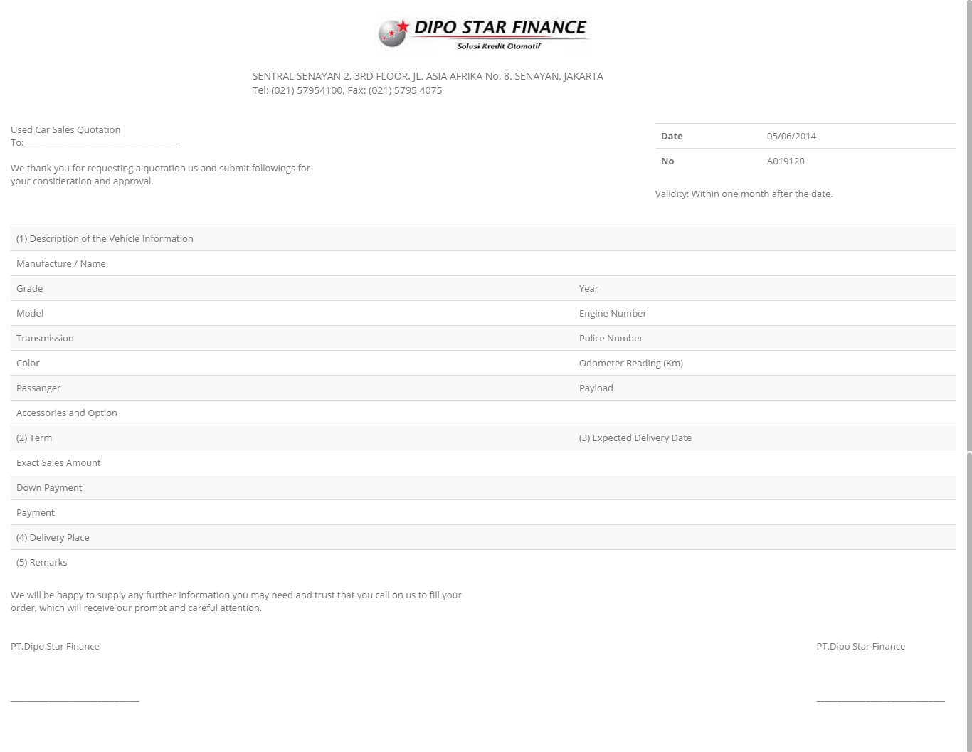

Image 9 – Screen of Refinance Quotation Report

* + 1. **Screen features**

|  |  |
| --- | --- |
| **Features** | **Description** |
| [Filter and sort] | To perform data filtering and data sorting of calculation records. |
| [Create new] | To create new Refinance quotations by entry data on create new form. |
| [Save as draft] or [Set to draft] | To save a quotation as a draft. |
| [Submit] | To submit a quotation record as a final. |
| [Save changes] | To update of changes when editing Refinance quotation record. |
| [View detail] | To inspect a detail Refinance quotation records by opens a view detail form. |
| [Edit] | To update of Refinance quotation record. |
| [Validate] | To validate of Refinance quotation. |
| [Preview and Print] | To preview and print the report. |

* + 1. **Data structure**

|  |  |  |  |  |
| --- | --- | --- | --- | --- |
| **Field** | **Data Type** | **Data Length** | **Format** | **Mandatory** |
| **Calculation Identity** | | | | |
| Calculation of Refinance Number | Text | 50 | N/A | *Yes* |
| Buyer/ Customer Name | Text | 100 | N/A | *Yes* |
| **Product Basic Information** | | | | |
| Product Registration Code | Text | 50 | N/A | *Yes* |
| Product Type | Text | 100 | N/A | *Yes* |
| Product Category | Text | 50 | N/A | *Yes* |
| Product Brand Code | Text | 50 | N/A | *Yes* |
| Product Brand Name | Text | 100 | N/A | *Yes* |
| Product Model Code | Text | 100 | N/A | *Yes* |
| Product Model Name | Text | 100 | N/A | *Yes* |
| Product Model Type | Text | 100 | N/A | *Yes* |
| Product Model Year | Date | N/A | mm-yyyy | *Yes* |
| Transmission | Text | 100 | N/A | *Yes* |
| Fuel Type | Text | 100 | N/A | *Yes* |
| Displacement (cc) | Text | 100 | N/A | *Yes* |
| Maximum Loading Capacity | Number | 50 | N/A | *No* |
| Product Category | Text | 100 | N/A | *No* |
| Number Plate Color | Text | 100 | N/A | *No* |
| Usage | Text | 100 | N/A | *No* |
| Location | Text | 100 | N/A | *No* |
| Schedule Date for Registration | Decimal | 18,3 | mm-dd-yyyy | *No* |
| Registration Date | Date | N/A | mm-dd-yyyy | *No* |
| **Quotation Information** | | | | |
| Valid Until | Date | N/A | mm-dd-yyyy | *No* |
| Terms | Text | 200 | N/A | *Yes* |
| Expected Delivery Date | Date | N/A | mm-dd-yyyy | *No* |
| Down Payment | Decimal | 18,3 | ###,###,###.## | *No* |
| Delivery Place | Text | 100 | N/A | *No* |
| Remarks | Text | 200 | N/A | *No* |
| **Audit Rail** | | | | |
| Create By | Text | 100 | N/A | *Yes* |
| Create Date | Date time | N/A | mm-dd-yyyy:hh-mm-ss | *No* |
| Last Modified By | Text | 100 | N/A | *Yes* |
| Last Modified | Date time | N/A | mm-dd-yyyy:hh-mm-ss | *No* |
| **Status Management** | | | | |
| Is Deleted | Yes/No | N/A | N/A | *Yes* |
| Is Draft | Yes/No | N/A | N/A | *Yes* |
| Is Submitted | Yes/No | N/A | N/A | *Yes* |
| Is Valid | Yes/No | N/A | N/A | *Yes* |

* 1. Calculation of Operating Lease
     1. **Use case**

The figure below is summarizing who uses features of function, and what they can do with it.

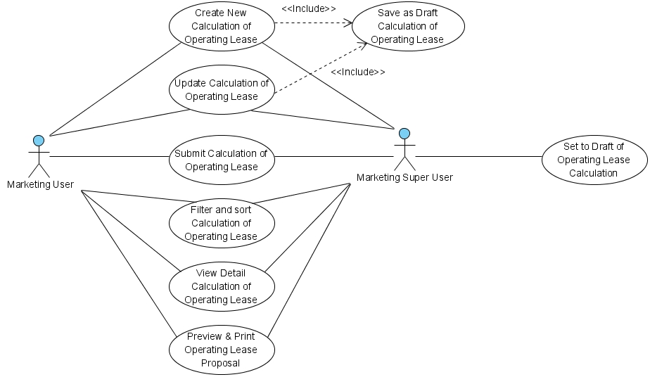

Figure 9 – Use case diagram of Calculation of Operating Lease

* + 1. **Operations and scenarios**

The figure below is describing operations or steps performed in a function interact with people (flow of work between actors and the system).

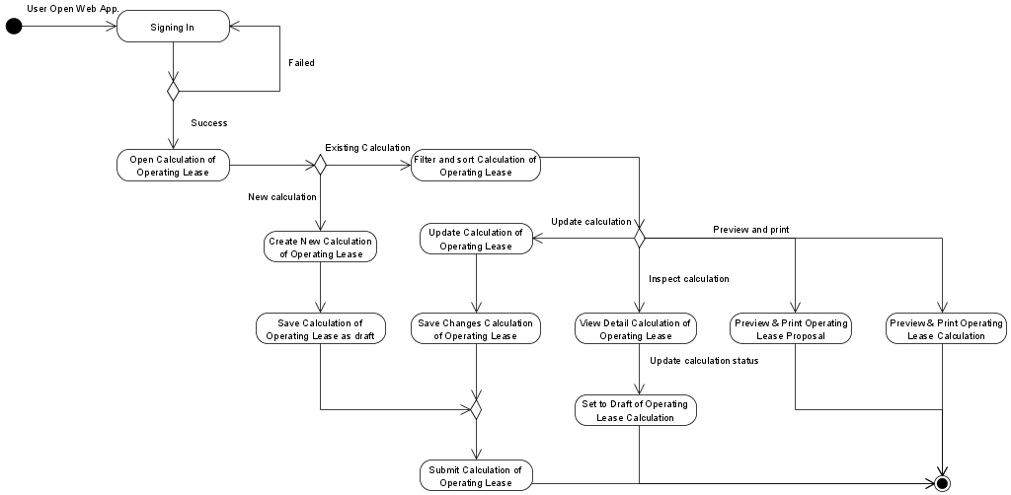

Figure 10 – Activity diagram of Calculation of Operating Lease

|  |  |  |  |
| --- | --- | --- | --- |
| **No.** | **Steps/ Operations** | **Actor/ People** | **Scenario** |
| 1 | Signing in | Marketing user, Marketing super user | * Actor fills out sign in form by inputting user name and password. * Actor clicks [sign in] button. System will check the account of user; if user account is already registered user will enter into the system. If doesn’t user can return the step. |
| 2. | Open calculation of operating lease module | Marketing user, Marketing super user | * After login, actor can open calculation of operating lease module on the menu of system. After that, screen of calculation of operating lease will open. * After screen opens, list of operating lease calculation will be shown and calculation data existing will be displayed. |
| 3. | Create new calculation of operating lease | Marketing user, Marketing super user | * If calculation screen opens, actor can click [create] button to create new records of calculation and after that create calculation screen will open. * Once create calculation opens, the actors can fill out a form that is divided into 5 steps:  1. Step-1; on this step product information and basic lease information should be identified first before continuing to the next step. To fill out product information and customer field actor can click […] button at the fields. Upon clicking […] button at look-up window will be shown. These windows have features to search and select the record. At least one record must be selected. On this step actor cannot move to the next step, if data has not been saved as draft. If it is done, click [next step] button to continue to Step-2 screen. 2. Step 2; basic cost condition and finance condition can be identified on this screen. Data can be input manually one by one. If it is done, click [next step] button to continue to Step-3 3. Step-3; if maintenance type selected is other than non-maintenance, cost maintenance can be identified by input manually. Total Maintenance Cost will be calculated automatically. If it is done, click [next step] button to continue to Step-4 screen. 4. Step-4, on this screen insurance data should be identified by input manually. Total insurance fee will be calculated automatically. If it is done, click [next step] button to continue to last screen. 5. On the Step-5, this screen is final step, after fill out the calculation fields on the Step-1 to Step-4, the calculation result will be displayed can calculated automatically.  * The mandatory fields cannot be blank. * If done, actor can click [Back] button to return to the list of operating lease calculation, then calculation data will be displayed. |
| 4. | Save calculation of operating lease as draft | Marketing user, Marketing super user | * After filling out the fields on the Step-1, actor can click [save as draft] button, if want to make a records as **draft**. After that inputting data process can be continued to another screen. * Once [save as draft] button clicking, system will proceed to store a data into database and will automatically check a validity of data (such as; data type, mandatory data, and data length) * If done, actor can click [Back] button to return to the list of Refinance calculation, then calculation data will be displayed. |
| 5 | Submit calculation of operating lease | Marketing user, Marketing super user | * Once data is saved and data has been confirmed, actor can submit the record by clicking [Submit] button. * After that system will set a calculation record as **submitted (or not draft)**. * If done, actor can click [Back] button to return to the list of operating lease calculation, then calculation data will be displayed. |
| 6. | Update calculation of operating lease | Marketing user, Marketing super user | * On the calculation of Refinance screen actor can click [Edit] button to update the calculation record by editing data on the edit calculation screen. * If there were calculation still draft, *marketing user* can click [edit] button on the right side of the records on the list of operating lease calculation. * If there were calculation record already submits and the status is **valid**, *marketing user* cannot click [edit] button to open edit calculation screen. * If edit calculation screen opens, actor can edit a record by inputting a data on each of the fields. * The mandatory fields cannot be blank. |
| 7. | Filter and sort calculation of operating lease | Marketing user, Marketing super user | * Actor can filter and sort the calculation record based on columns where displayed on the list of operating lease calculation. * To filter calculation records, actor can enter keywords into the filter fields. If matched data founds, the filtered result will be displayed on list. If doesn’t the list of operating lease calculation will be empty. * To sort calculation records, actor can click header of column on the list table. After that the records will be sorted by ascending or descending, alternately. * Upon select [record number filter] drop down list, actor can select a record number to display on the list of operating lease calculation. At least only one item can be selected. |
| 8. | View detail calculation of operating lease | Marketing user, Marketing super user | * On the calculation screen actor can open view detail calculation screen to inspect a data. * On the list of Refinance calculation screen, actor can click [view detail] button, after that system will display a screen of calculation detail. * On this screen, actor cannot do anything to edit of data. Only viewing calculation record. * There are 2 conditions when calculation detail screen opens:  1. If calculation status is still **draft** or already **valid**, [validate] button and [set to draft] button will be disappeared. 2. If calculation status was already **submitted**, [validate] button and [set to draft] button will be shown.  * If done, actor can click [Back] button to return to the list of operating lease calculation, then calculation data will be displayed. |
| 9 | Set to draft of operating lease calculation | Marketing super user | * To utilize this feature; If calculation still need to revise and status still not valid yet, actor can change the calculation status from **submitted** to **draft**. * To do this process, actor should open calculation detail screen by clicking [view detail] button in the list of operating lease calculation screen. Once calculation detail screen opens, actor can change the status of calculation by clicking [set to draft] button. After that, system will proceed automatically to change the status on database. * If done, actor can click [Back] button to return to the list of operating lease calculation, then calculation data will be displayed. |
| 10 | Preview and print operating lease proposal | Marketing user, Marketing super user | * To produce this report, actor can select the calculation record on the list and select the report on group button by click [Print preview] button (at lease only one record can be selected). Once it clicked preview screen will be opened. * Upon preview screen opens, actor can click [Print] button to print the report. * If done, actor can click [Back] button to return to the list of operating lease calculation, then calculation data will be displayed. |

* + 1. **Status management and roles**

The figure below is describing a role matrix (including relation with Status) of actor that already identified in a function.

|  |  |  |  |  |  |  |  |
| --- | --- | --- | --- | --- | --- | --- | --- |
| **Role of Actor** | **Filter and sort** | **Save as draft** | **Save changes**  **(draft)** | **Save changes**  **(submitted)** | **Submit** | **Validate** | **Preview and print** |
| Marketing super user | Yes | Yes | Yes | Yes | Yes | Yes | Yes |
| Marketing user | Yes | Yes | Yes | No | Yes | No | Yes |

The figure below is describing transition of Status that performed when people interact in a function. In this features, validation (validate and invalidate) process triggered on the operating lease quotation module. If the quotation already validate, so the status of calculation will be valid too, and vice versa.

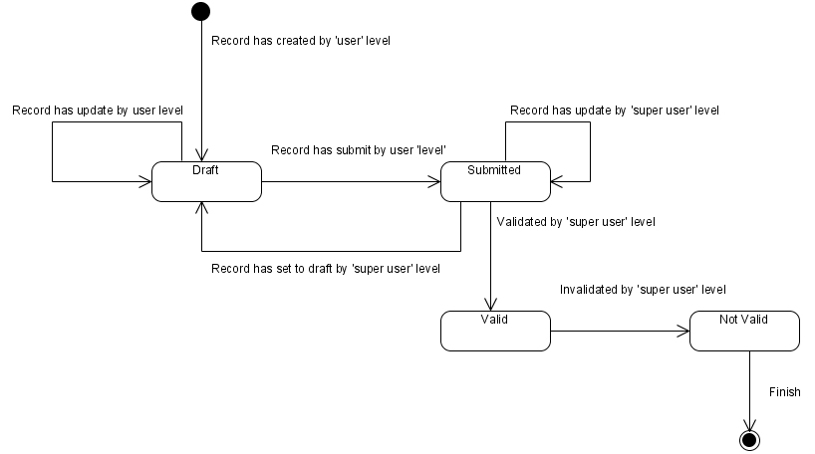

Figure 11 – Status diagram of Operating Lease Calculation

* + 1. **Sitemap design**

Describe a web page that lists the pages on a web site to users. Usually sitemap organized in hierarchical style.

Figure 12 – Sitemap design of Operating Lease Calculation

* + 1. **Screen design**
       1. **List of operating lease calculation**

This screen is designed to display a calculation of Refinance list. On this list actor can filter and sort a calculation records. And also, actor can open another screen to create new calculation record, update calculation record, and view detail of calculation record.

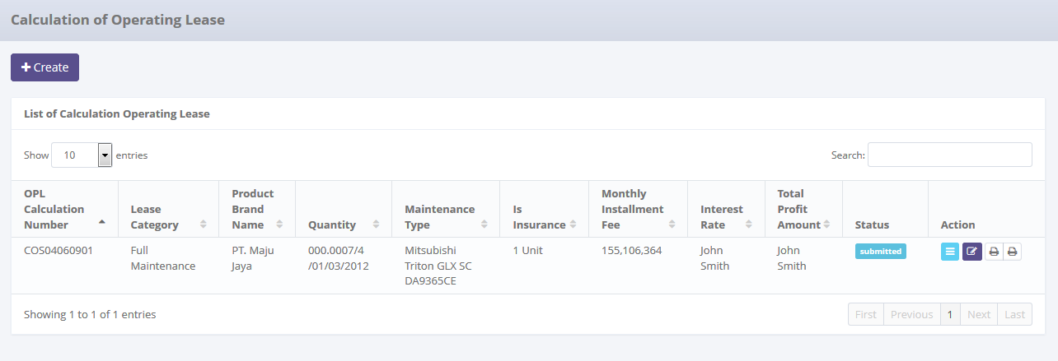

To create new records

To filter a number of record filter button

To open paging the records

Data paging information

To filter records

To open edit or view detail records

Displaying list

Image 10 – List of Operating Lease Calculation Screen

* + - 1. **Create new calculation of operating lease**

This screen is designed to create new calculation of Refinance record. After filling out necessary data on the screen, actor can store a data into the system by clicking the action button.

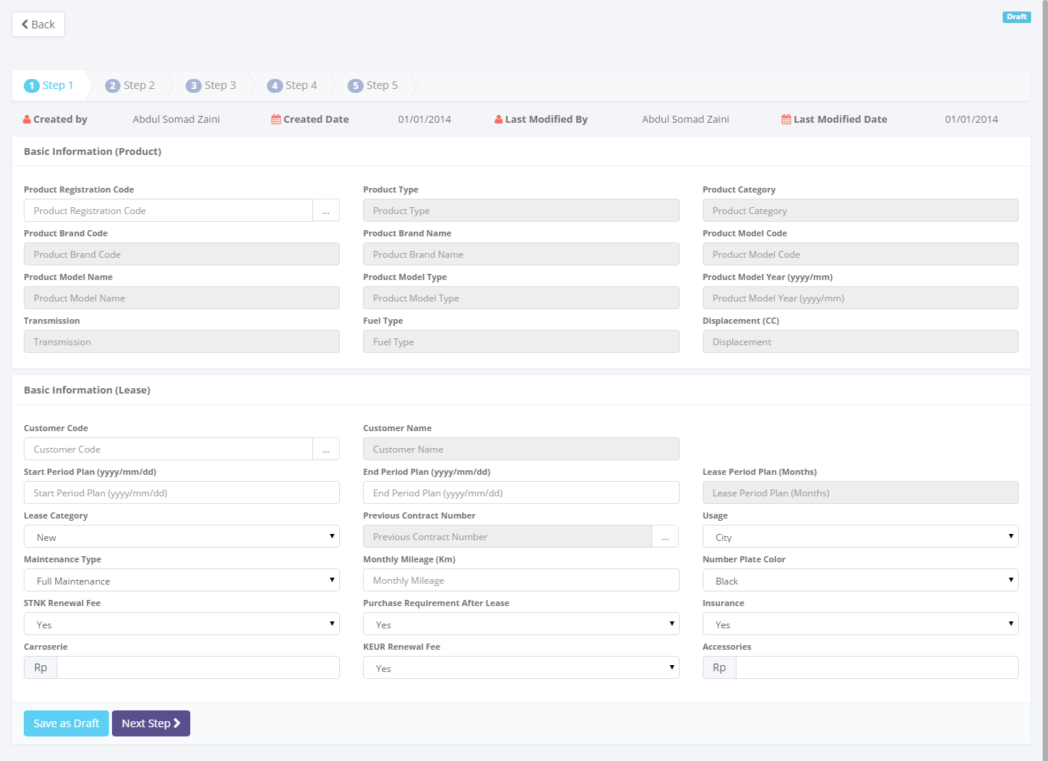

Return back to list of operating lease calculation

To save and navigate the calculation data

To entry a calculation data

Image 11 – Screen of Create New Operating Lease Calculation Screen (Step 1)

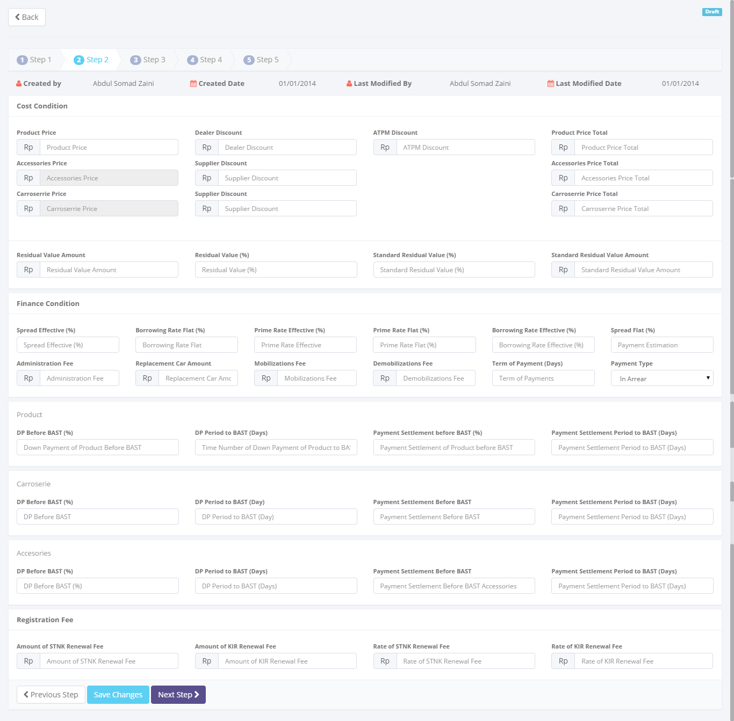

To save and navigate the calculation data

To entry a calculation data

Return back to list of operating lease calculation

Image 12 – Screen of Create New Operating Lease Calculation Screen (Step 2)

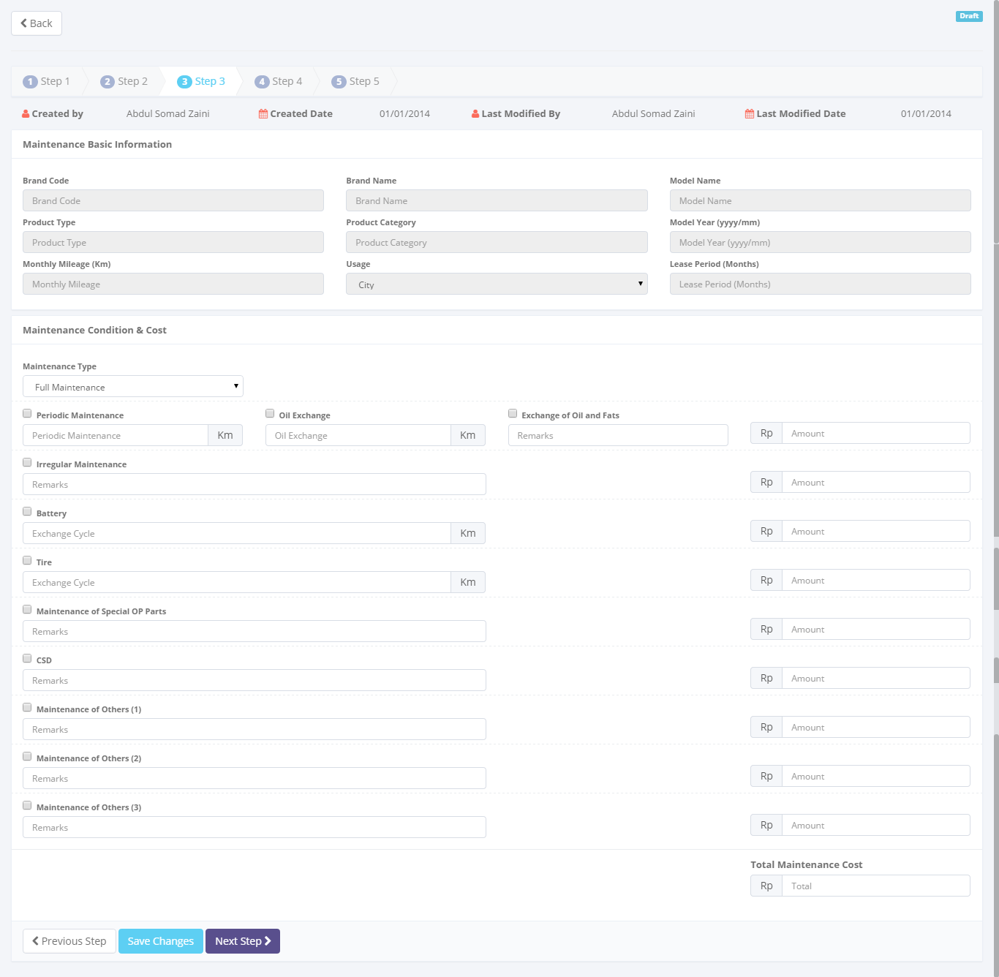

To save and navigate the calculation data

Return back to list of operating lease calculation

To entry a calculation data

Image 13 – Screen of Create New Operating Lease Calculation Screen (Step 3)

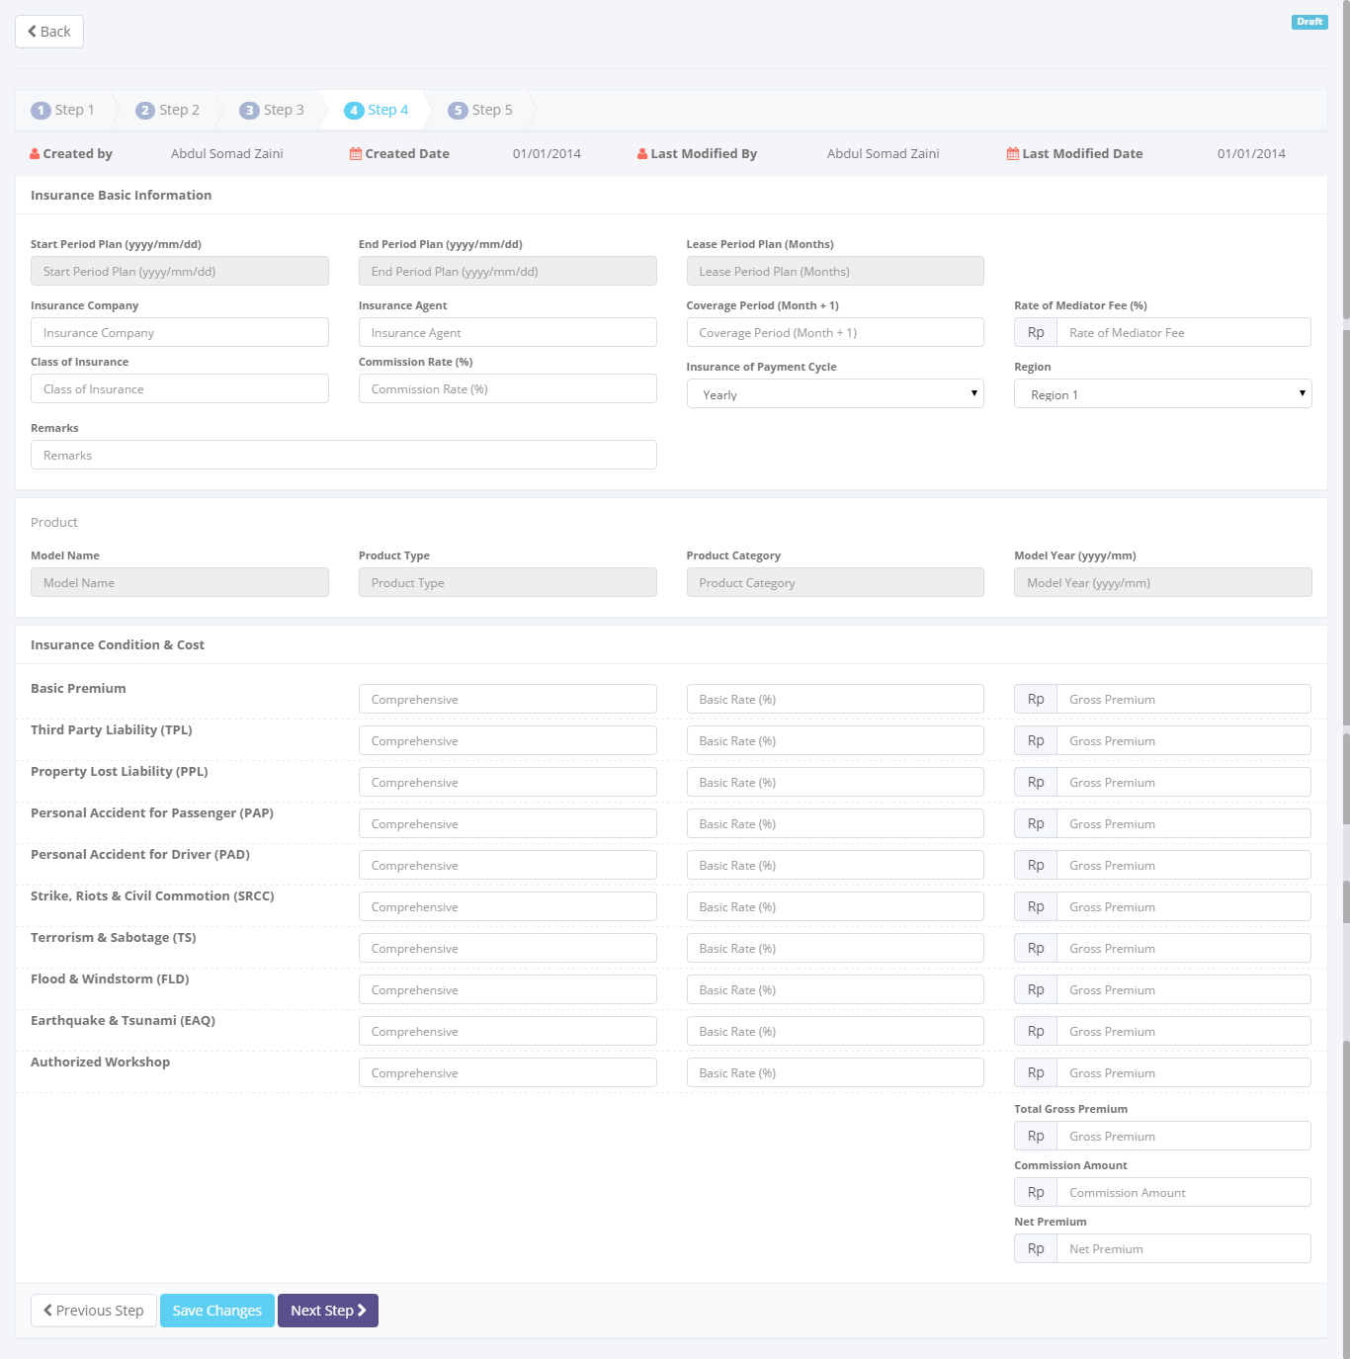

To save and navigate the calculation data

To entry a calculation data

Return back to list of operating lease calculation

Image 14 – Screen of Create New Operating Lease Calculation Screen (Step 4)

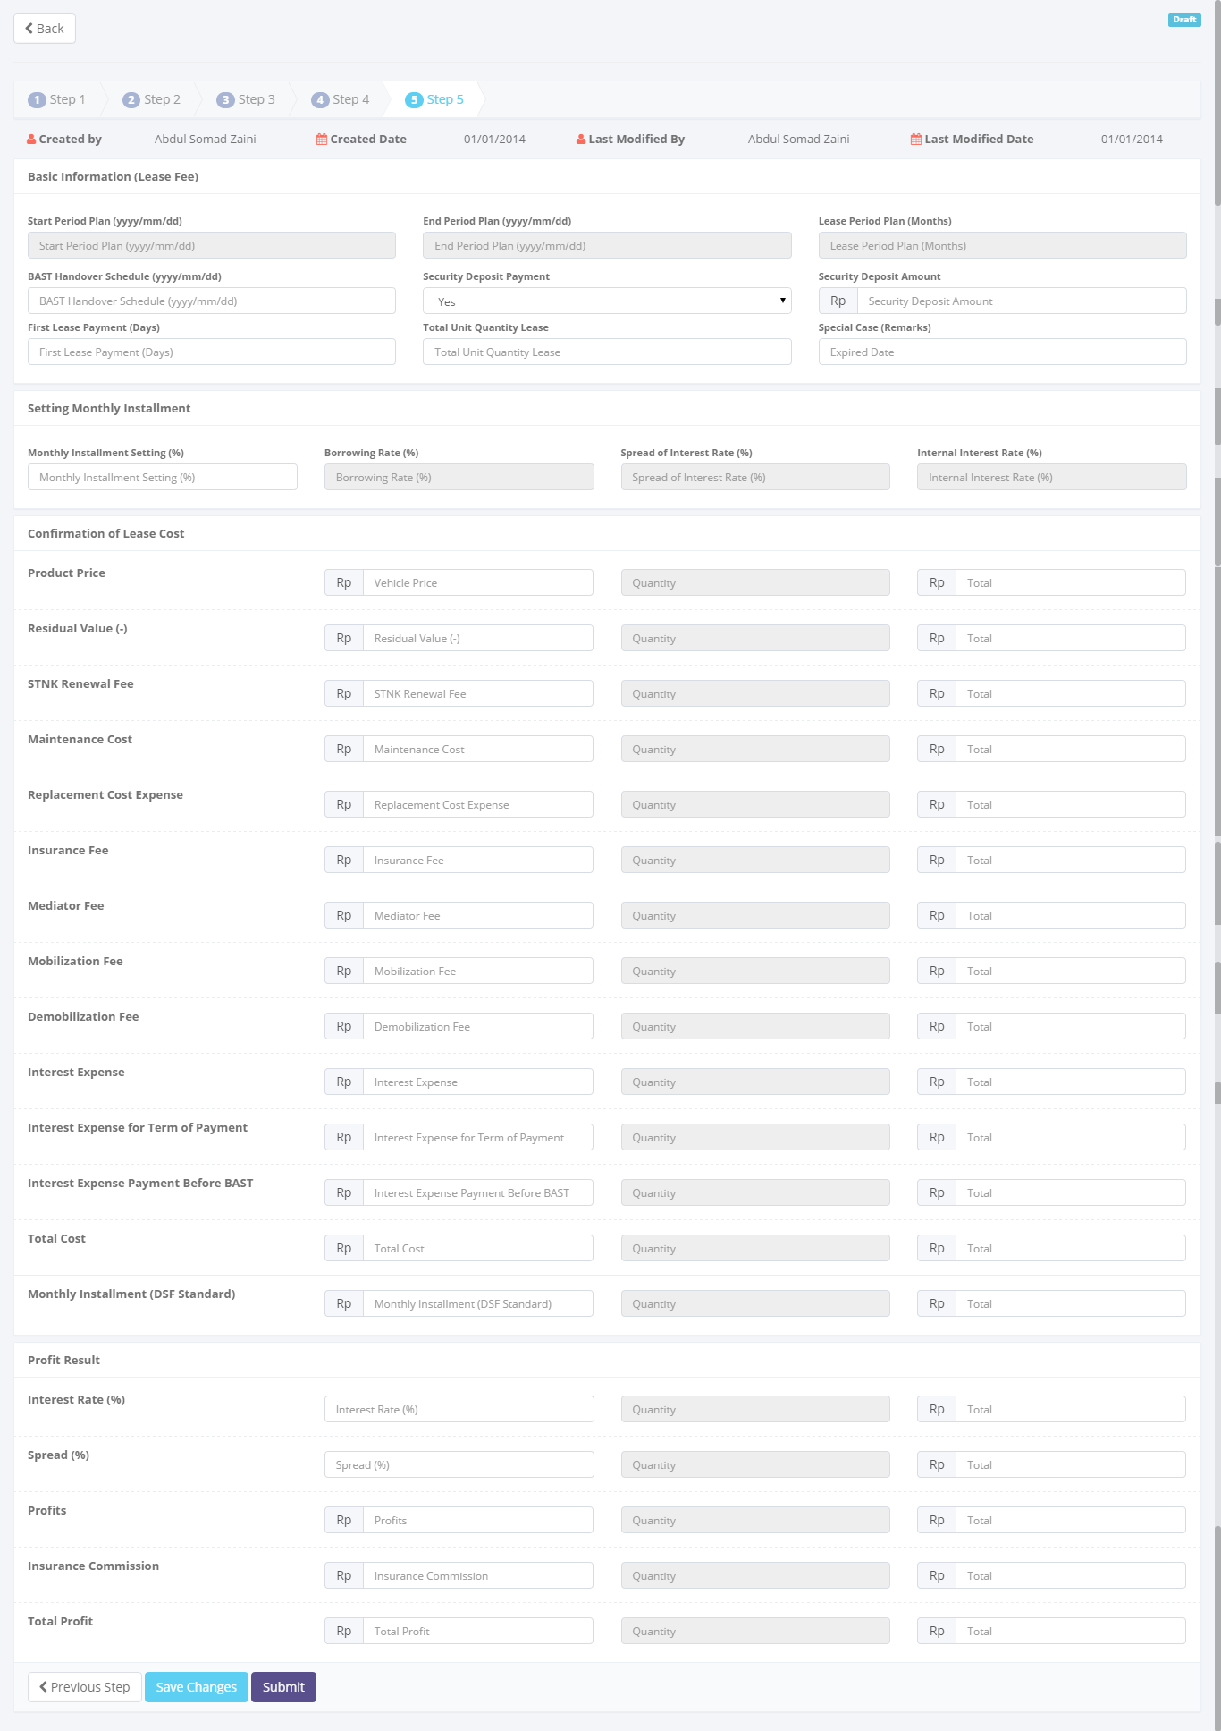

Return back to list of operating lease calculation

To entry a calculation data

To save and navigate the calculation data

Image 15 – Screen of Create New Operating Lease Calculation Screen (Step 5)

* + - 1. **Update calculation of operating lease**

This screen is designed to update calculation of Refinance. After changing some data on the screen, actor can store a data into the system by clicking the action button.

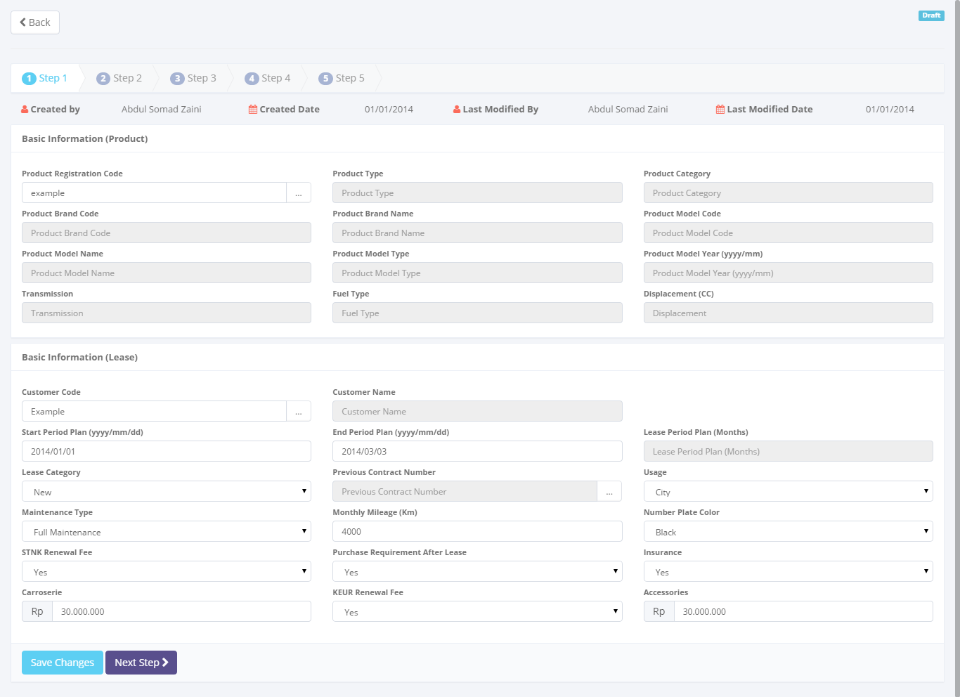

To save and navigate the calculation data

To entry a calculation data

Return back to list of operating lease calculation

Image 16 – Screen of Update Operating Lease Calculation screen (Step 1)

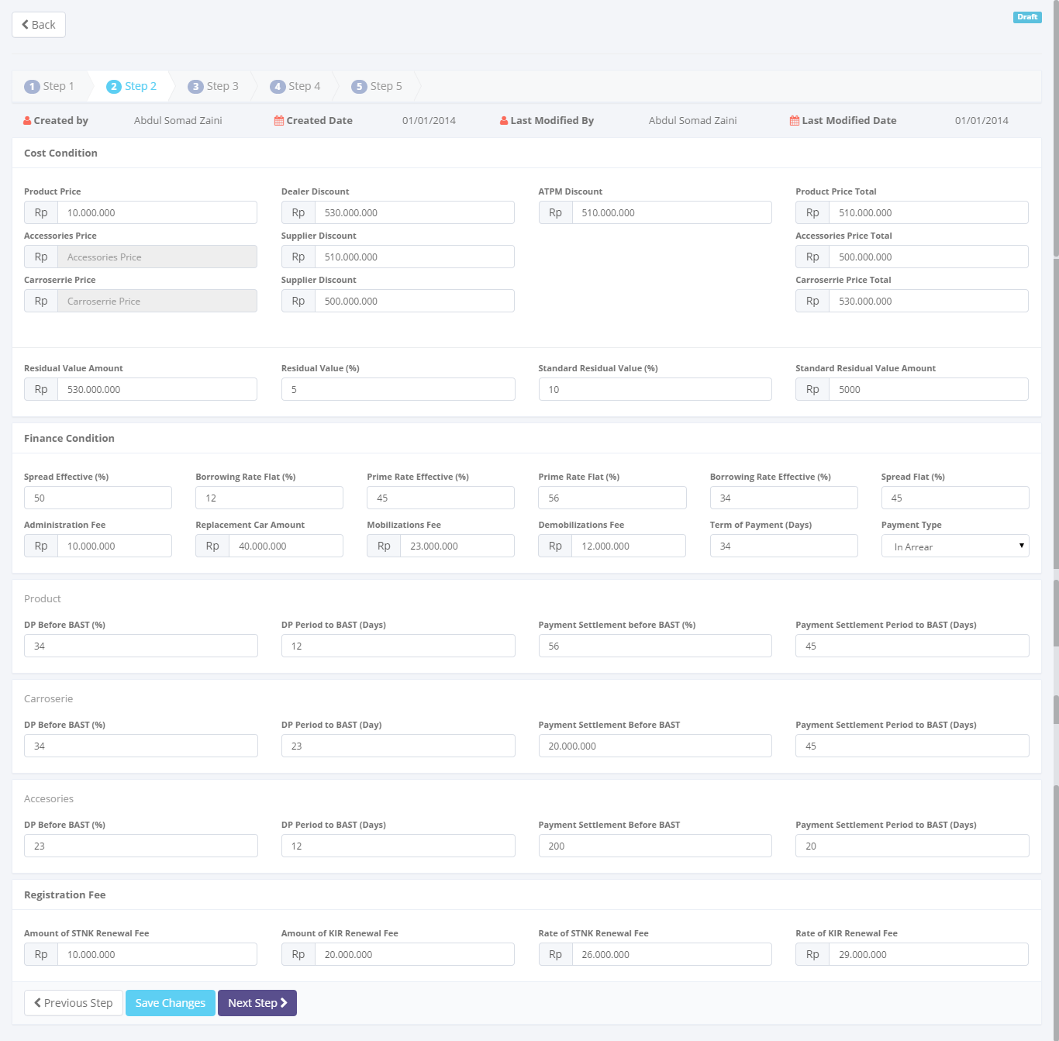

To save and navigate the calculation data

Return back to list of operating lease calculation

To entry a calculation data

Image 17 – Screen of Update Operating Lease Calculation screen (Step 2)

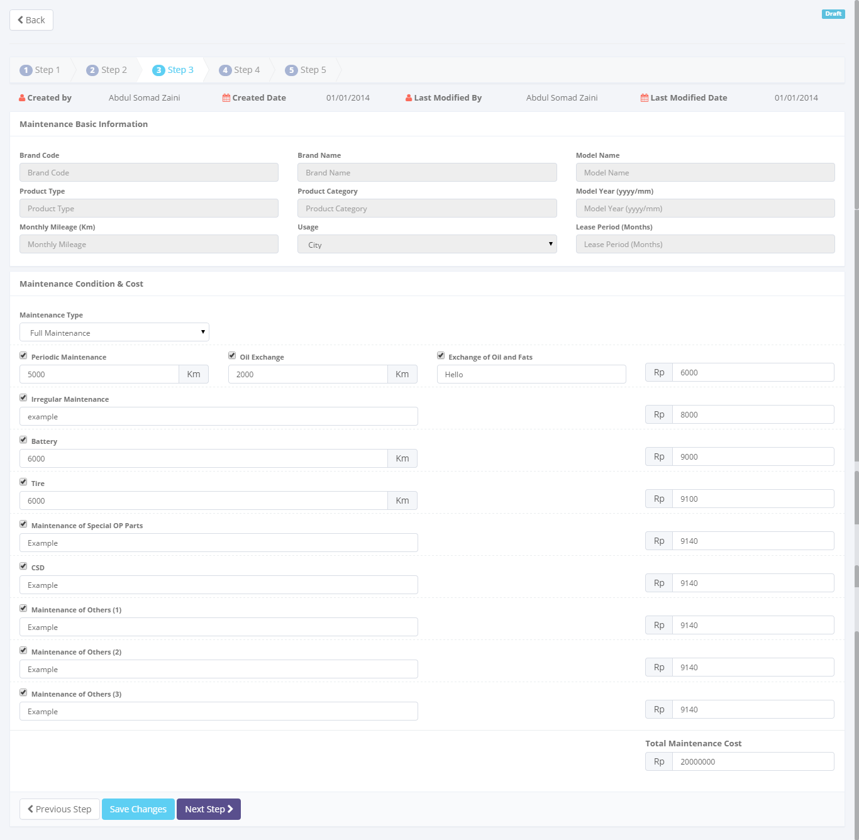

To save and navigate the calculation data

Return back to list of operating lease calculation

To entry a calculation data

Image 18 – Screen of Update Operating Lease Calculation screen (Step 3)

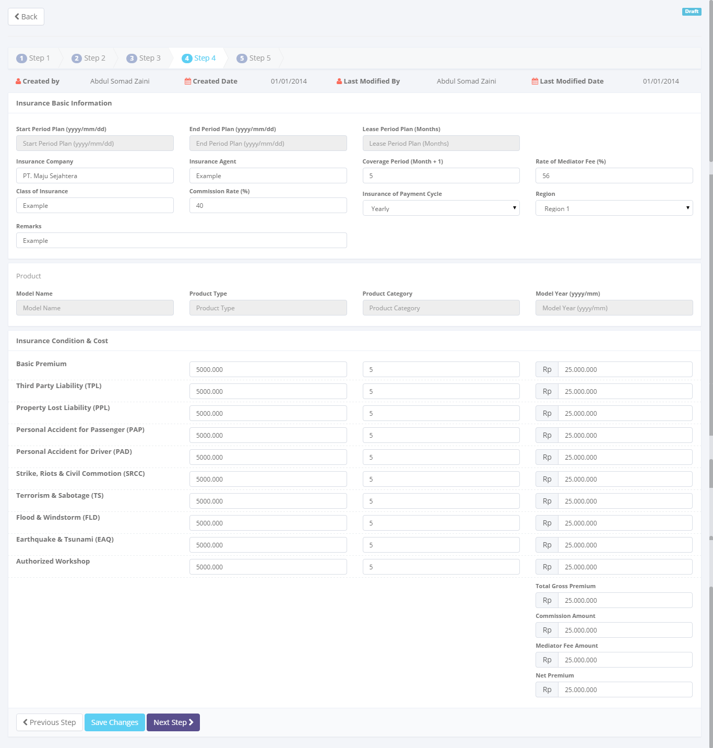

To save and navigate the calculation data

To entry a calculation data

Return back to list of operating lease calculation

Image 19 – Screen of Update Operating Lease Calculation screen (Step 4)

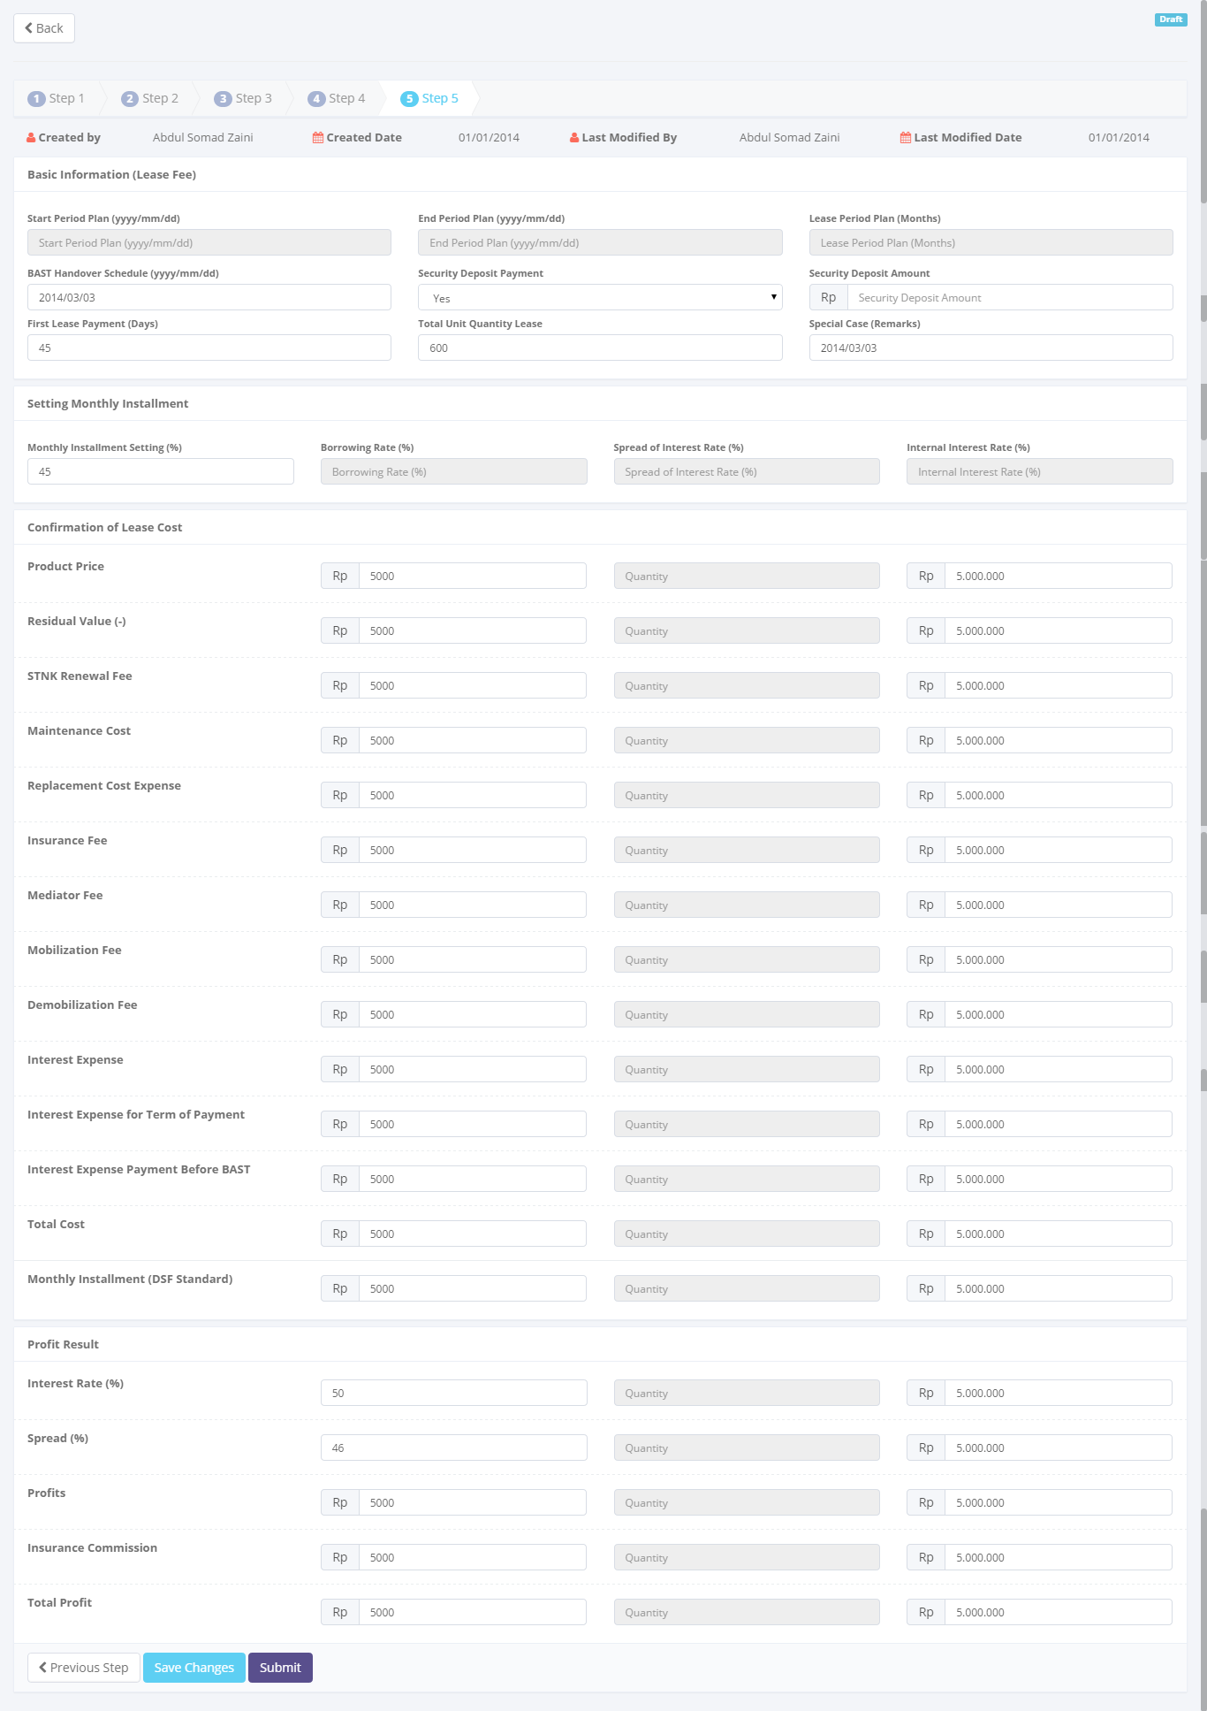

To save and navigate the calculation data

To entry a calculation data

Return back to list of operating lease calculation

Image 20 – Screen of Update Operating Lease Calculation screen (Step 5)

* + - 1. **View detail calculation of operating lease**

This screen is designed to view detail a calculation of Refinance. On this screen actor can change status of a Refinance calculation by clicking action button.

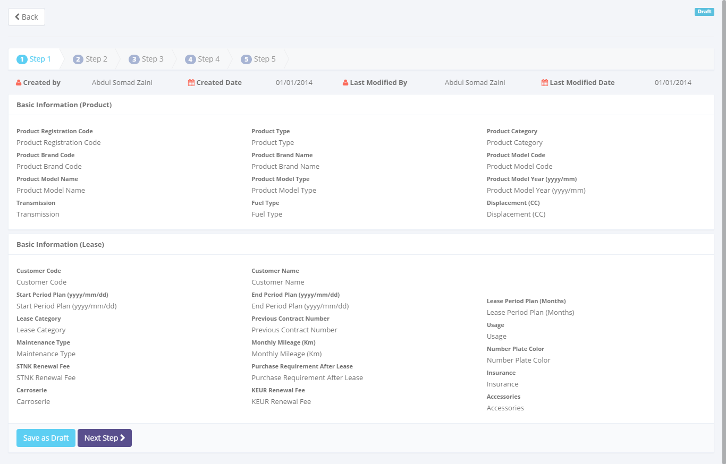

A detail calculation data

To navigate the calculation data

Return back to list of operating lease calculation

Image 21 – Screen of View Detail Operating Lease Calculation (Step 1)

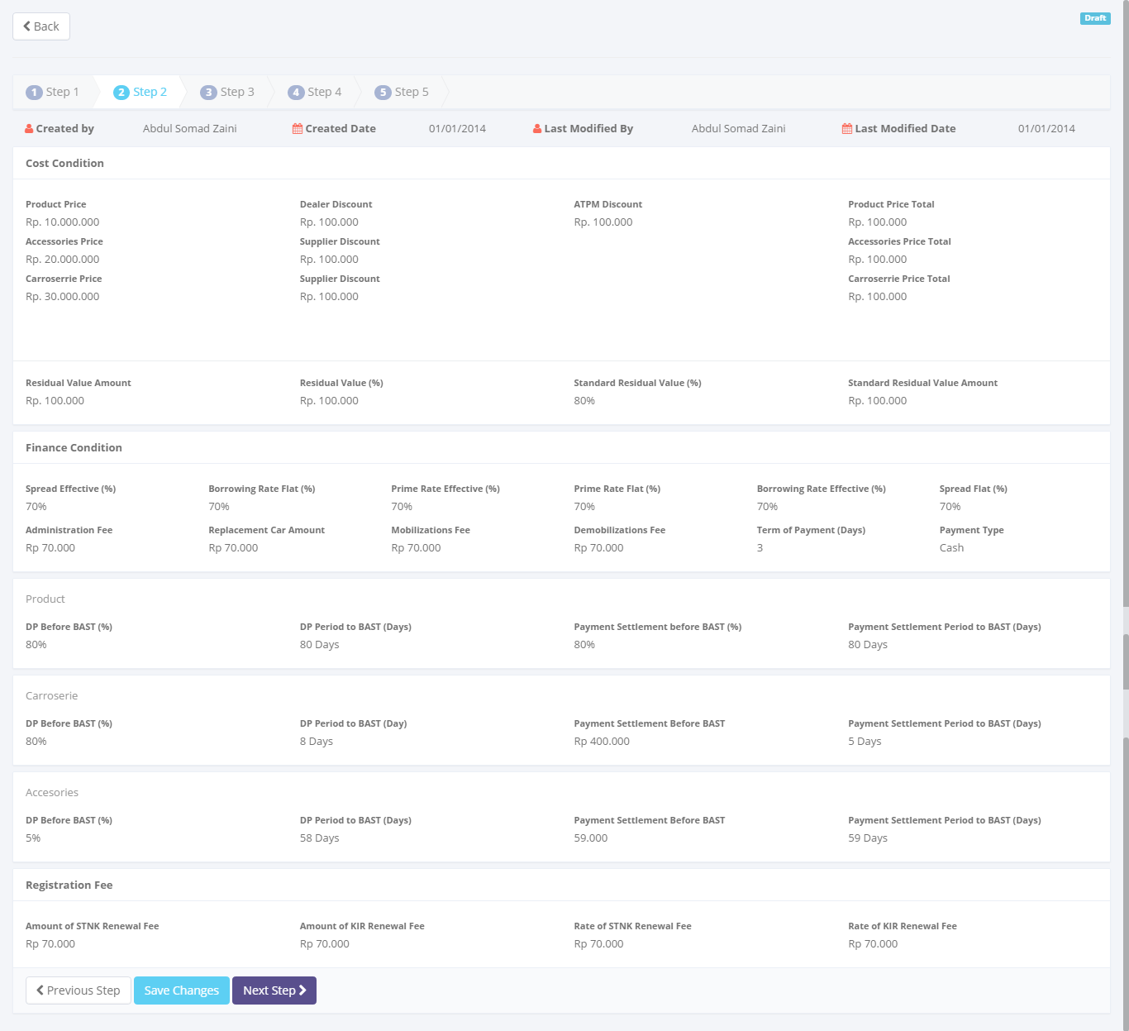

To navigate the calculation data

A detail calculation data

Return back to list of operating lease calculation

Image 22 – Screen of View Detail Operating Lease Calculation (Step 2)

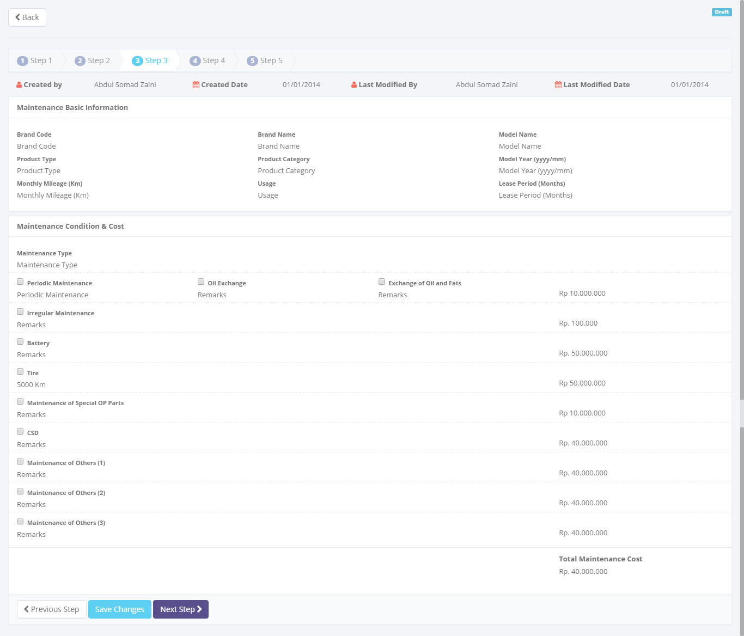

To navigate the calculation data

A detail calculation data

Return back to list of operating lease calculation

Image 23 – Screen of View Detail Operating Lease Calculation (Step 3)

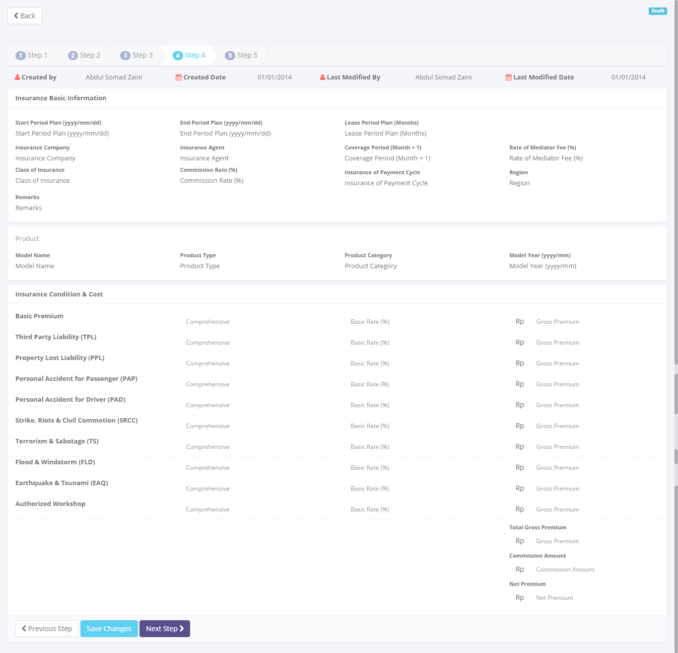

To navigate the calculation data

A detail calculation data

Return back to list of operating lease calculation

Image 24 – Screen of View Detail Operating Lease Calculation (Step 4)

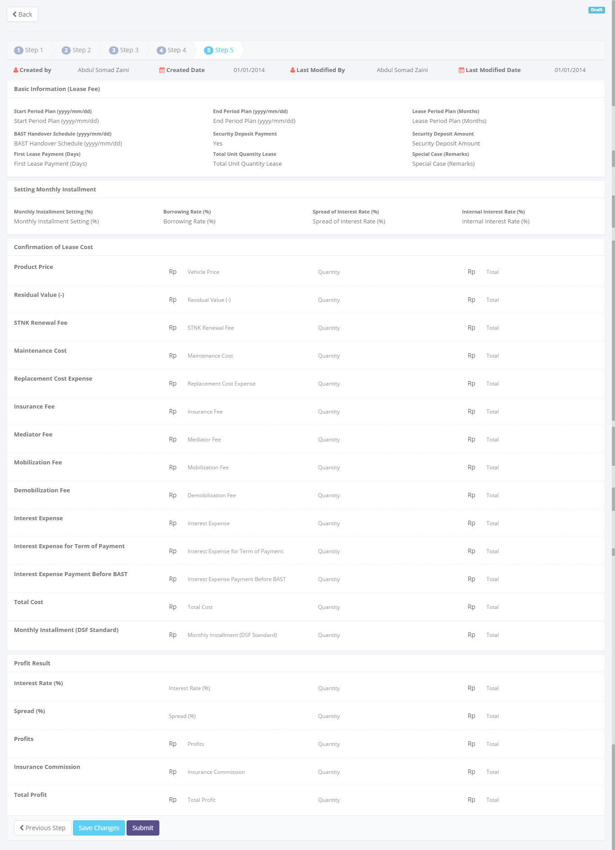

To navigate the calculation data

A detail calculation data

Return back to list of operating lease calculation

Image 25 – Screen of View Detail Operating Lease Calculation (Step 5)

* + - 1. **Preview and print operating lease calculation**

This screen is designed to view detail a calculation of Refinance. On this screen actor can change status of a Refinance calculation by clicking action button.

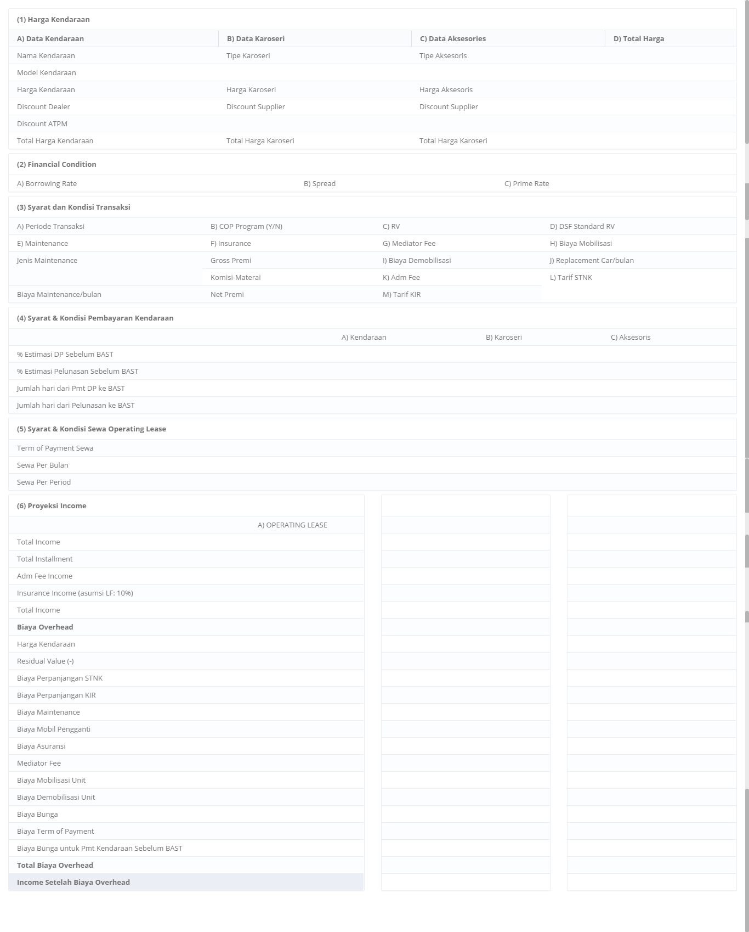

Image 26 – Screen of Operating Lease Calculation Report

* + - 1. **Preview and print operating lease proposal**

This screen is designed to view detail a calculation of Refinance. On this screen actor can change status of a Refinance calculation by clicking action button.

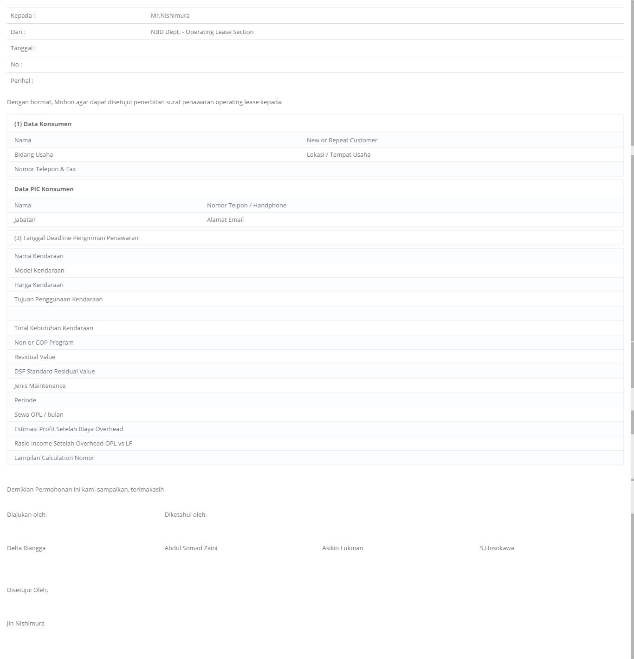

Image 30 – Screen of Preview and Print Operating Lease Calculation

* + 1. **Screen features**

|  |  |
| --- | --- |
| **Features** | **Description** |
| [Filter and sort] | To perform data filtering and data sorting of calculation records. |
| [Create new] | To create new calculations by entering data on create new calculation form. |
| [Save as draft] or [Set to draft] | To save a calculation as a draft. |
| [Submit] | To submit a calculation record as a final. |
| [Save changes] | To update changes when editing calculation record. |
| [View detail] | To inspect a detail calculation records by opening a calculation detail form. |
| [Edit] | To update of calculation record. |
| [Preview and Print] | To preview and print the report. |

* + 1. **Data structure**

|  |  |  |  |  |
| --- | --- | --- | --- | --- |
| **Field** | **Data Type** | **Data Length** | **Format** | **Mandatory** |
| **Product Basic Information** | | | | |
| Product Registration Code | Text | 50 | N/A | *Yes* |
| Product Type | Text | 100 | N/A | *Yes* |
| Product Category | Text | 50 | N/A | *Yes* |
| Product Brand Code | Text | 50 | N/A | *Yes* |
| Product Brand Name | Text | 100 | N/A | *Yes* |
| Product Model Code | Text | 100 | N/A | *Yes* |
| Product Model Name | Text | 100 | N/A | *Yes* |
| Product Model Type | Text | 100 | N/A | *Yes* |
| Product Model Year | Date | N/A | mm-yyyy | *Yes* |
| Transmission | Text | 100 | N/A | *Yes* |
| Fuel Type | Text | 100 | N/A | *Yes* |
| Displacement (cc) | Text | 100 | N/A | *Yes* |
| **Lease Basic Information** | | | | |
| Customer Code | Text | 50 | N/A | *Yes* |
| Customer Name | Text | 200 | N/A | *Yes* |
| Start Period Plan | Date | N/A | mm-dd-yyyy | *Yes* |
| End Period Plan | Date | N/A | mm-dd-yyyy | *Yes* |
| Lease Period Plan | Number | N/A | N/A | *Yes* |
| Lease Category | Text | 100 | N/A | *Yes* |
| Previous Contract Number | Text | 50 | N/A | *Yes* |
| Usage | Text | 100 | N/A | *Yes* |
| Maintenance Type | Text | 100 | N/A | *Yes* |
| Monthly Mileage | Number | N/A | N/A | *Yes* |
| Number Plate Color | Text | 100 | N/A | *Yes* |
| STNK Renewal Fee | Yes/ No | N/A | N/A | *Yes* |
| Purchase Requirement After Lease | Yes/ No | N/A | N/A | *Yes* |
| Insurance | Yes/ No | N/A | N/A | *Yes* |
| KEUR Renewal | Yes/ No | N/A | N/A | *Yes* |
| BAST Handover Schedule | Date | N/A | mm-yyyy | *No* |
| Security Deposit Payment | Decimal | 18,3 | ###,###,###.## | *No* |
| Security Deposit Amount | Decimal | 18,3 | ###,###,###.## | *No* |
| First Lease Payment | Decimal | 18,3 | ###,###,###.## | *No* |
| Total Unit Quantity Lease | Decimal | 18,3 | ###,###,###.## | *No* |
| Special Case (remarks) | Text | 200 | N/A | *No* |
| **Cost Condition** | | | | |
| Product Price | Decimal | 18,3 | ###,###,###.## | *No* |
| Dealer Discount | Decimal | 18,3 | ###,###,###.## | *No* |
| ATPM Discount | Decimal | 18,3 | ###,###,###.## | *No* |
| Accessories Price | Decimal | 18,3 | ###,###,###.## | *No* |
| Accessories Supplier Discount | Decimal | 18,3 | ###,###,###.## | *No* |
| Carroserrie Price | Decimal | 18,3 | ###,###,###.## | *No* |
| Carroserrie Supplier Discount | Decimal | 18,3 | ###,###,###.## | *No* |
| Product Price Total | Decimal | 18,3 | ###,###,###.## | *No* |
| Accessories Price Total | Decimal | 18,3 | ###,###,###.## | *No* |
| Carroserrie Price Total | Decimal | 18,3 | ###,###,###.## | *No* |
| Residual Value Amount | Decimal | 18,3 | ###,###,###.## | *No* |
| Residual Rate Value | Decimal | 18,3 | ###,###,###.## | *No* |
| Standard Residual Rate Value | Decimal | 18,3 | ###,###,###.## | *No* |
| Standard Residual Value Amount | Decimal | 18,3 | ###,###,###.## | *No* |
| **Basic Finance Condition** | | | | |
| Spread Effective Percent | Decimal | 18,3 | ###,###,###.## | *No* |
| Borrowing Rate Flat Percent | Decimal | 18,3 | ###,###,###.## | *No* |
| Prime Rate Effective | Decimal | 18,3 | ###,###,###.## | *No* |
| Prime Rate Flat | Decimal | 18,3 | ###,###,###.## | *No* |
| Borrowing Rate Effective | Decimal | 18,3 | ###,###,###.## | *No* |
| Spread Flat | Decimal | 18,3 | ###,###,###.## | *No* |
| Administration Fee | Decimal | 18,3 | ###,###,###.## | *No* |
| Replacement Car Amount | Decimal | 18,3 | ###,###,###.## | *No* |
| Mobilizations Fee Amount | Decimal | 18,3 | ###,###,###.## | *No* |
| Demobilizations Fee Amount | Decimal | 18,3 | ###,###,###.## | *No* |
| Term of Payment | Decimal | 18,3 | ###,###,###.## | *No* |
| Payment Type | Text | 100 | N/A | *No* |
| **Product Finance Condition** | | | | |
| DP Before BAST Percent | Decimal | 18,3 | ###,###,###.## | *No* |
| DP Period to BAST | Number | N/A | N/A | *No* |
| Payment Settlement Before BAST | Decimal | 18,3 | ###,###,###.## | *No* |
| Payment Settlement Period to BAST | Number | N/A | N/A | *No* |
| **Carroserrie Finance Condition** | | | | |
| DP Before BAST | Decimal | 18,3 | ###,###,###.## | *No* |
| DP Period to BAST | Number | N/A | N/A | *No* |
| Payment Settlement Before BAST | Decimal | 18,3 | ###,###,###.## | *No* |
| Payment Settlement Period to BAST | Number | N/A | N/A | *No* |
| **Accessories Finance Condition** | | | | |
| DP Before BAST | Decimal | 18,3 | ###,###,###.## | *No* |
| DP Period to BAST | Number | N/A | N/A | *No* |
| Payment Settlement Before BAST | Decimal | 18,3 | ###,###,###.## | *No* |
| Payment Settlement Period to BAST | Number | N/A | N/A | *No* |
| **Registration Fee Condition** | | | | |
| STNK Renewal Fee Amount | Decimal | 18,3 | ###,###,###.## | *No* |
| KIR Renewal Fee Amount | Decimal | 18,3 | ###,###,###.## | *No* |
| Rate of STNK Renewal | Decimal | 18,3 | ###,###,###.## | *No* |
| Rate of KIR Renewal Fee Amount | Decimal | 18,3 | ###,###,###.## | *No* |
| **Maintenance Condition & Cost** | | | | |
| Maintenance Type | Text | 100 | N/A | *No* |
| Periodic Maintenance | Number | N/A | N/A | *No* |
| Oil Exchange | Number | N/A | N/A | *No* |
| Exchange Oil & Fats | Number | N/A | N/A | *No* |
| Regular Maintenance Amount | Decimal | 18,3 | ###,###,###.## | *No* |
| Irregular Maintenance Remarks | Text | 100 | N/A | *No* |
| Irregular Maintenance Amount | Decimal | 18,3 | ###,###,###.## | *No* |
| Battery Maintenance | Text | 100 | N/A | *No* |
| Battery Maintenance Amount | Decimal | 18,3 | ###,###,###.## | *No* |
| Tire Maintenance | Text | 100 | N/A | *No* |
| Tire Maintenance Amount | Decimal | 18,3 | ###,###,###.## | *No* |
| Special Parts Maintenance | Text | 100 | N/A | *No* |
| Special Parts Maintenance Amount | Decimal | 18,3 | ###,###,###.## | *No* |
| CSD Remarks | Text | 100 | N/A | *No* |
| CSD Amount | Decimal | 18,3 | ###,###,###.## | *No* |
| Other Maintenance Remarks | Text | 100 | N/A | *No* |
| Other Maintenance Amount | Decimal | 18,3 | ###,###,###.## | *No* |
| Total Maintenance Cost | Decimal | 18,3 | ###,###,###.## | *No* |
| **Insurance Basic Information** | | | | |
| Start Period Plan | Text | 100 | N/A | *No* |
| End Period Plan | Decimal | 18,3 | ###,###,###.## | *No* |
| Lease Period Plan | Decimal | 18,3 | ###,###,###.## | *No* |
| Insurance Company | Text | 100 | N/A | *No* |
| Insurance Agent | Text | 100 | N/A | *No* |
| Coverage Period Month +1 | Number | N/A | N/A | *No* |
| Mediator Fee Rate | Decimal | 18,3 | ###,###,###.## | *No* |
| Insurance Class | Text | 100 | N/A | *No* |
| Commission Rate | Decimal | 18,3 | ###,###,###.## | *No* |
| Insurance Payment Cycle | Text | 100 | N/A | *No* |
| Region | Text | 100 | N/A | *No* |
| **Insurance Condition Cost** | | | | |
| Basic Premium Rate | Decimal | 18,3 | ###,###,###.## | *No* |
| Basic Premium Amount | Decimal | 18,3 | ###,###,###.## | *No* |
| Third Party Liability (TPL) Rate | Decimal | 18,3 | ###,###,###.## | *No* |
| Third Party Liability (TPL) Amount | Decimal | 18,3 | ###,###,###.## | *No* |
| Property Lost Liability (PLL) Rate | Decimal | 18,3 | ###,###,###.## | *No* |
| Property Lost Liability (PLL) Amount | Decimal | 18,3 | ###,###,###.## | *No* |
| Personal Accident for Passenger (PAP) Rate | Decimal | 18,3 | ###,###,###.## | *No* |
| Personal Accident for Passenger (PAP) Amount | Decimal | 18,3 | ###,###,###.## | *No* |
| Personal Accident for Driver (PAD) Rate | Decimal | 18,3 | ###,###,###.## | *No* |
| Personal Accident for Driver (PAD) Amount | Decimal | 18,3 | ###,###,###.## | *No* |
| Strike, Riots, Civil Commotions (SRCC) Rate | Decimal | 18,3 | ###,###,###.## | *No* |
| Strike, Riots, Civil Commotions (SRCC) Amount | Decimal | 18,3 | ###,###,###.## | *No* |
| Terrorism & Sabotage (TS) Rate | Decimal | 18,3 | ###,###,###.## | *No* |
| Terrorism & Sabotage (TS) Amount | Decimal | 18,3 | ###,###,###.## | *No* |
| Flood & Windstorm (FLD/W) Rate | Decimal | 18,3 | ###,###,###.## | *No* |
| Flood & Windstorm (FLD/W) Amount | Decimal | 18,3 | ###,###,###.## | *No* |
| Earthquake & Tsunami (EAQ/T) Rate | Decimal | 18,3 | ###,###,###.## | *No* |
| Earthquake & Tsunami (EAQ/T) Amount | Decimal | 18,3 | ###,###,###.## | *No* |
| Authorized Workshop Rate | Decimal | 18,3 | ###,###,###.## | *No* |
| Authorized Workshop Amount | Decimal | 18,3 | ###,###,###.## | *No* |
| Insurance Total Gross Premium | Decimal | 18,3 | ###,###,###.## | *No* |
| Insurance Net Premium | Decimal | 18,3 | ###,###,###.## | *No* |
| Commission Amount | Decimal | 18,3 | ###,###,###.## | *No* |
| Mediator Fee Amount | Decimal | 18,3 | ###,###,###.## | *No* |
| **Monthly Installment Setting** | | | | |
| Monthly Installment Rate | Decimal | 18,3 | ###,###,###.## | *No* |
| Borrowing Rate | Decimal | 18,3 | ###,###,###.## | *No* |
| Spread Interest Rate | Decimal | 18,3 | ###,###,###.## | *No* |
| Internal Interest Rate | Decimal | 18,3 | ###,###,###.## | *No* |
| **Confirmation of Lease Cost** | | | | |
| Product Price Amount | Decimal | 18,3 | ###,###,###.## | *No* |
| Residual Value Amount | Decimal | 18,3 | ###,###,###.## | *No* |
| STNK Renewal Fee Amount | Decimal | 18,3 | ###,###,###.## | *No* |
| Maintenance Cost Amount | Decimal | 18,3 | ###,###,###.## | *No* |
| Replacement Cost Amount | Decimal | 18,3 | ###,###,###.## | *No* |
| Insurance Fee Amount | Decimal | 18,3 | ###,###,###.## | *No* |
| Mediator Fee Amount | Decimal | 18,3 | ###,###,###.## | *No* |
| Mobilization Fee Amount | Decimal | 18,3 | ###,###,###.## | *No* |
| Demobilization Fee Amount | Decimal | 18,3 | ###,###,###.## | *No* |
| Interest Amount | Decimal | 18,3 | ###,###,###.## | *No* |
| Interest of Term of Payment Amount | Decimal | 18,3 | ###,###,###.## | *No* |
| Interest of Payment Before BAST Amount | Decimal | 18,3 | ###,###,###.## | *No* |
| Total Cost | Decimal | 18,3 | ###,###,###.## | *No* |
| Monthly Installment Standard (DSF) | Decimal | 18,3 | ###,###,###.## | *No* |
| **Profit Result** | | | | |
| Interest Rate | Decimal | 18,3 | ###,###,###.## | *No* |
| Spread Interest Rate | Decimal | 18,3 | ###,###,###.## | *No* |
| Profit Amount | Decimal | 18,3 | ###,###,###.## | *No* |
| Insurance Commission Amount | Decimal | 18,3 | ###,###,###.## | *No* |
| Total Profit Amount | Decimal | 18,3 | ###,###,###.## | *No* |
| **Audit Rail** | | | | |
| Create By | Text | 100 | N/A | *Yes* |
| Create Date | Date time | N/A | mm-dd-yyyy:hh-mm-ss | *No* |
| Last Modified By | Text | 100 | N/A | *Yes* |
| Last Modified | Date time | N/A | mm-dd-yyyy:hh-mm-ss | *No* |
| **Status Management** | | | | |
| Is Deleted | Yes/No | N/A | N/A | *Yes* |
| Is Draft | Yes/No | N/A | N/A | *Yes* |
| Is Submitted | Yes/No | N/A | N/A | *Yes* |
| Is Valid | Yes/No | N/A | N/A | *Yes* |

* 1. Operating Lease Quotation
     1. **Use case**

The figure below is summarizing who uses features of function, and what they can do with it.

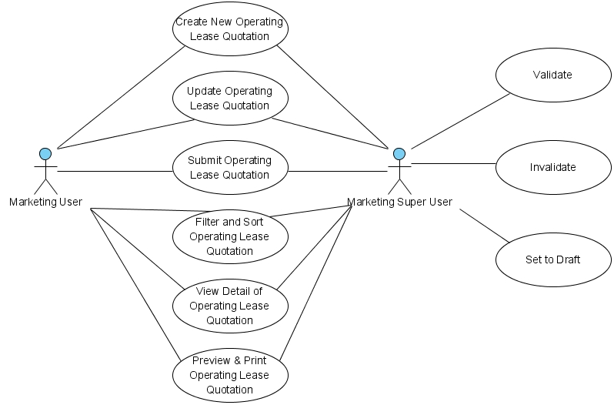

Figure 13 – Use case diagram of Operating Lease Quotation

* + 1. **Operations and scenarios**

The figure below is describing operations or steps performed in a function interact with people (flow of work between actors and the system).

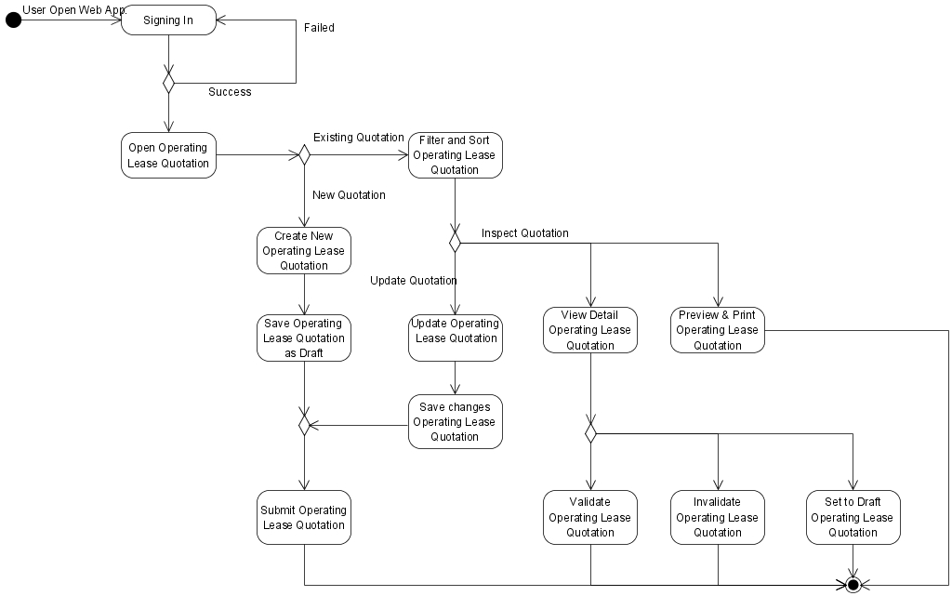

Figure 14 – Activity diagram of Operating Lease Quotation

|  |  |  |  |
| --- | --- | --- | --- |
| **No.** | **Steps/ Operations** | **Actor/ People** | **Scenario** |
| 1 | Signing in | Marketing user, Marketing super user | * Actor fills out sign in form by inputting user name and password. * Actor clicks [sign in] button. System will check the account of user; if user account is already registered user will enter into the system. If doesn’t user can return the step. |
| 2. | Open operating lease quotation module | Marketing user, Marketing super user | * After login, actor can open operating lease quotation module on the menu of system. After that, the screen will be open. * Once it is open, operating lease quotation list will be shown and existing data will be displayed. |
| 3. | Create new operating lease quotation | Marketing user, Marketing super user | * If list of operating lease quotation screen opens, actor can click [Create] button to create new quotation and after that create operating lease quotation screen will open. On this screen actor can specify the operating lease quotation records as basis to create the operating lease quotation. * To specify the operating lease quotation records, click […] button at calculation number, after that look-up window will be shown. These windows have features to search and select the calculation. At least one calculation must be selected. Once it done, actor can fill out other information on each field. * The mandatory fields cannot be blank. |
| 4. | Save operating lease quotation as draft | Marketing user, Marketing super user | * After filling out the fields, actor can click [Save as draft] button, if want to make a records as **draft**. * After that, system will proceed to store a data into database and will automatically check a validity of data (such as; data type, mandatory data, and data length) * If done, actor can click [Back] button to return to the list of operating lease quotation, then operating lease quotation data will be displayed. |
| 5 | Submit operating lease quotation record | Marketing user, Marketing super user | * Once data is saved and data has been confirmed, actor can submit the record by click [Submit] button. * After that system will set an operating lease quotation record as **submitted (or not draft)**. * If done, actor can click back button to return to the list of operating lease quotation. |
| 6. | Update operating lease quotation records | Marketing user, Marketing super user | * On the list of operating lease quotation screen actor can click [Edit] button to update the record by editing data on the edit screen. * If the quotations still **draft**, *marketing user* can click [Edit] button on the right side of the records on list of operating lease quotation screen. * If the quotation records already **submit** and the status is **valid**, *marketing user* cannot click [edit] button to open edit operating lease quotation screen. * If edit screen opens, actor can edit a record by inputting a data on each of the fields. * The mandatory fields cannot be blank. |
| 7. | Filter and sort operating lease quotation records | Marketing user, Marketing super user | * Actor can filter and sort the record based on columns where displayed on the list. * To filter the records, actor can enter keywords into the filter fields. If matched data founds, the result will be displayed on the list. If doesn’t, the list will be empty. * To sort the records, actor can click header of column on the list table. After that the records will be sorted by ascending or descending, alternately. * Upon select [Record number filter] drop down list, actor can filter a record number to display on the list. At least only one item can be selected. |
| 8. | View detail operating lease quotation record | Marketing user, Marketing super user | * On the list of operating lease quotation screen actor can view detail an operating lease quotation on the view detail screen. * To open view detail screen, actor can click [View detail] button, after that system will display a detail of operating lease quotation. On this screen, actor cannot do anything to edit of data. Only viewing the record. * There are 2 conditions when view detail screen opens:  1. If the quotation status is still **draft** or already **valid**, [Validate] button and [set to draft] button will be disappeared. 2. If quotation status was **submitted,** [Validate] button and [Set to draft] button will be shown.  * If done, actor can click back button to return to the list. |
| 9. | Validate Operating lease quotation | Marketing super user | * To do this process, actor should open view detail screen by clicking [View detail] button on the list. Once view detail screen opens, actor can change the status by clicking [validate] button. If quotation is already confirmed. After status changes to **valid**, actor cannot rollback the status to **submitted** or **draft**. * After that, system will proceed automatically to change the status, and actor can click [Back] button to return to the list. |
| 10. | Invalidate Operating lease quotation | Marketing super user | * In this feature (for the worst case), if quotation were made inoperative/ not applicable, actor can change the status from **valid** to **not valid**. * To do this process, actor should open view detail screen by clicking [View detail] button on the list. Once view detail screen opens, actor can change the status by clicking [Invalidate] button. * After that, system will proceed automatically to change the status, and actor can click [Back] button to return to the list. |
| 11. | Set to Draft of Operating lease quotation | Marketing super user | * To utilize this feature; If quotation still need to be revised and status still not valid yet, actor can change the status from **submitted** to **draft**. * To do this process, actor should open view detail screen by clicking [View detail] button on the list. Once view detail screen opens, actor can change the status by clicking [set to draft] button. * After that, system will proceed automatically to change the status, and actor can click [Back] button to return to the list. |
| 12. | Preview and print operating lease quotation | Marketing user, Marketing super user | * To do this process, actor can select the quotation record by clicking [Print preview] button, and after that the preview screen will be opened. * Once preview screen opens, actor can click [Print] button to print the report. |

* + 1. **Status management and roles**

The figure below is describing a role matrix (including relation with Status) of actor that already identified in a function.

|  |  |  |  |  |  |  |  |
| --- | --- | --- | --- | --- | --- | --- | --- |
| **Role of Actor** | **Filter and sort** | **Save as draft** | **Save changes**  **(draft)** | **Save changes**  **(submitted)** | **Submit** | **Validate** | **Preview & print** |
| Marketing super user | Yes | Yes | Yes | Yes | Yes | Yes | Yes |
| Marketing user | Yes | Yes | Yes | No | Yes | No | Yes |

The figure below is describing transition of Status that performed when people interact in a function. In this features, validation (validate and invalidate) process triggered on the operating lease quotation module. If the quotation already validate, so the status of operating lease quotation will be valid too, and vice versa.



Figure 15 – Status diagram of Operating Lease Quotation

* + 1. **Sitemap design**

Describe a web page that lists the pages on a web site to actors. Usually sitemap organized in hierarchical style.

Figure 16 – Sitemap design of Operating Lease Quotation

* + 1. **Screen design**
       1. **List of operating lease quotation**

This screen is designed to display a list of operating lease quotation. On this list actor can filter and sort a records. And also, actor can open another screen to create new quotation record, update quotation record, and view detail quotation record.

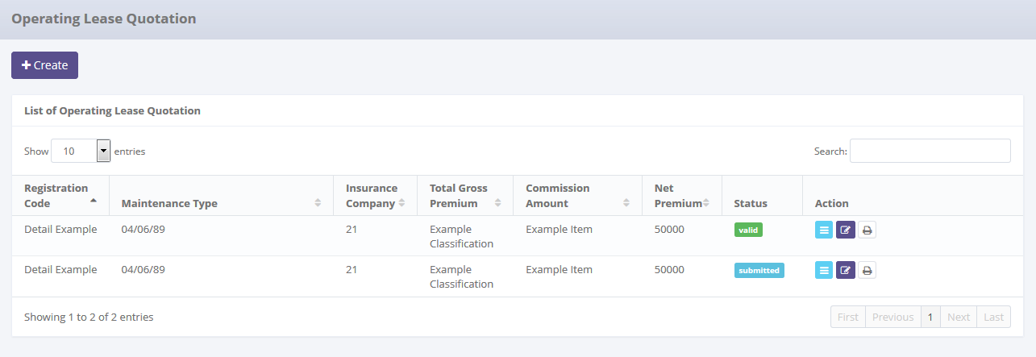

To open edit or view detail records

To open paging the records

Data paging information

Displaying list

To filter records

To filter a number of record filter button

To create new records

Image 31 – List of Operating Lease Quotation Screen

* + - 1. **Create new operating lease quotation**

This screen is designed to create new operating lease quotation record. After filling out necessary data on the screen, actor can store a data into the system by clicking the action button.

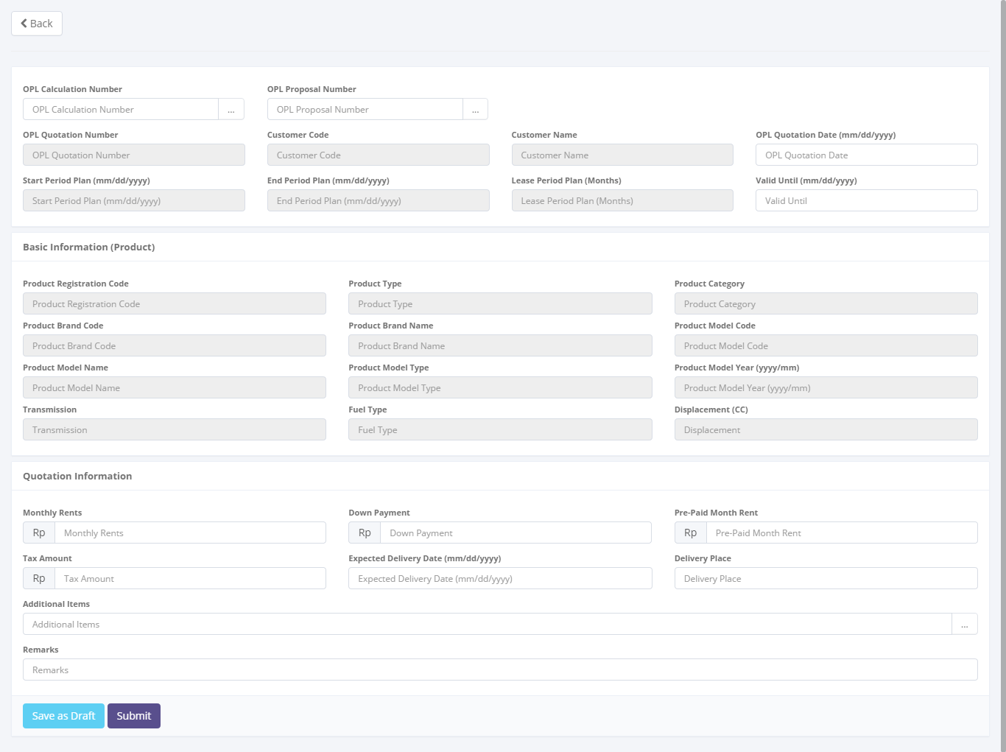

To save and navigate the quotation data

To entry a quotation data

Return back to list of operating lease quotation

Image 32 – Screen of Create New Operating Lease Quotation Screen

* + - 1. **Update operating lease quotation**

This screen is designed to update operating lease quotation. After changes some data on the screen, actor can store a data into the system by click the action button.

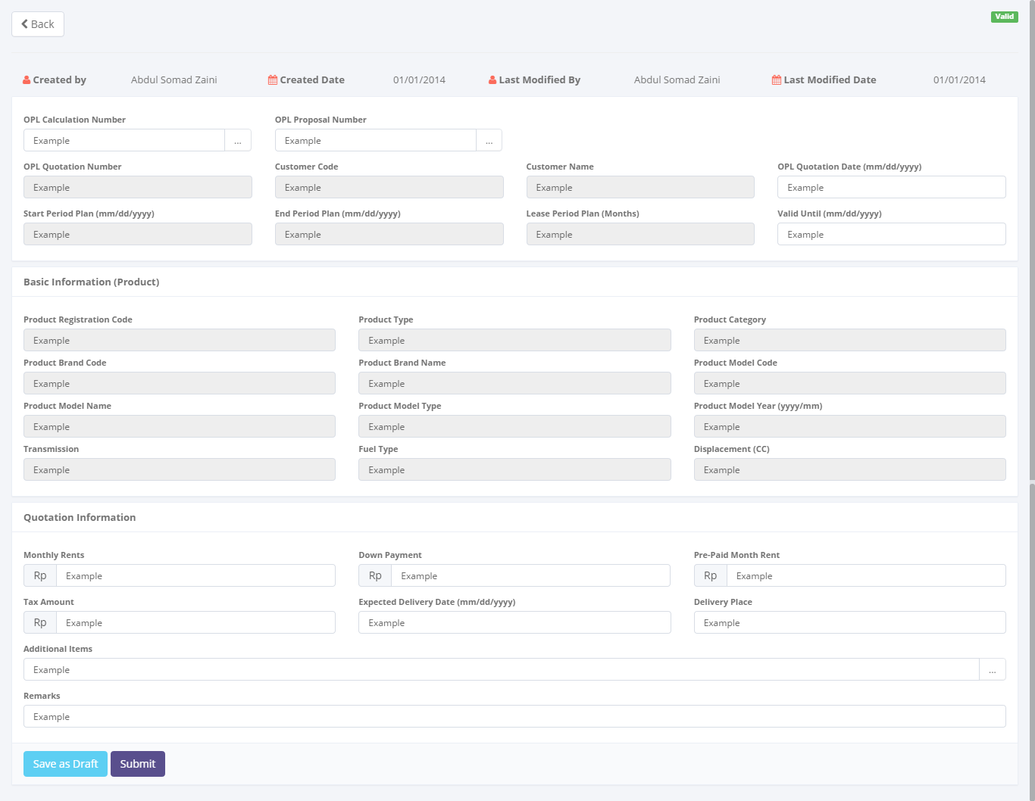

To save and navigate the calculation data

To entry a quotation data

Return back to list of operating lease quotation

Image 33 – Screen of Update Operating Lease Quotation Screen

* + - 1. **View detail operating lease quotation**

This screen is designed to view detail operating lease quotation. On this screen actor can change status of a operating lease quotation by clicking action button.

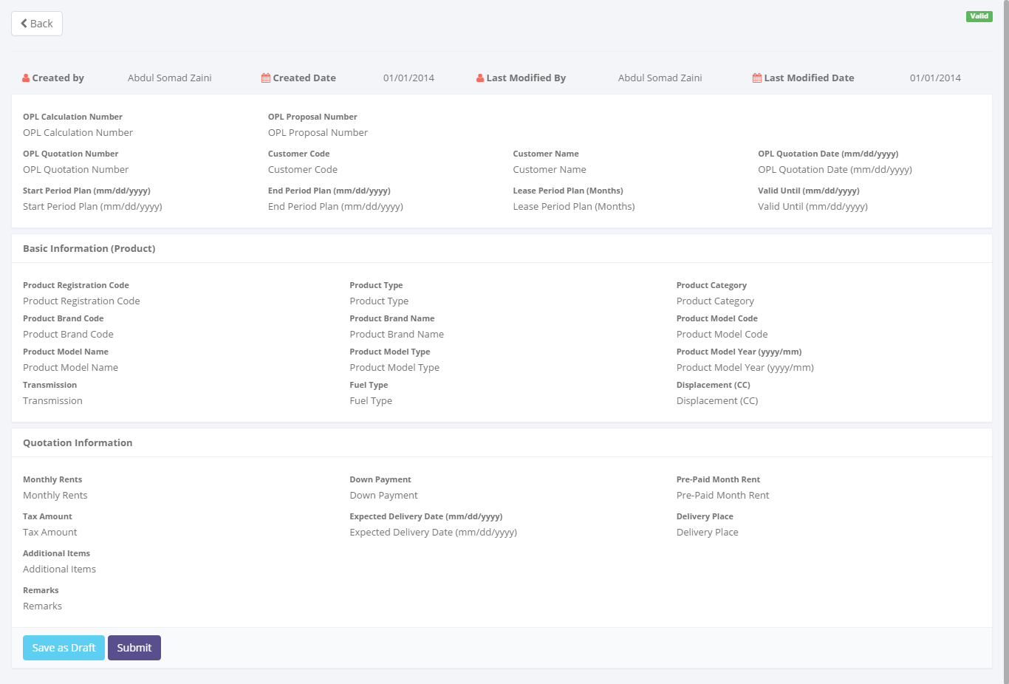

To save and navigate the calculation data

Return back to list of operating lease calculation

To entry a calculation data

Image 34 – Screen of View Detail Operating Lease Quotation

* + - 1. **Preview and print operating lease quotation**

This screen is designed to view detail operating lease quotation. On this screen actor can change status of a operating lease quotation by clicking action button.

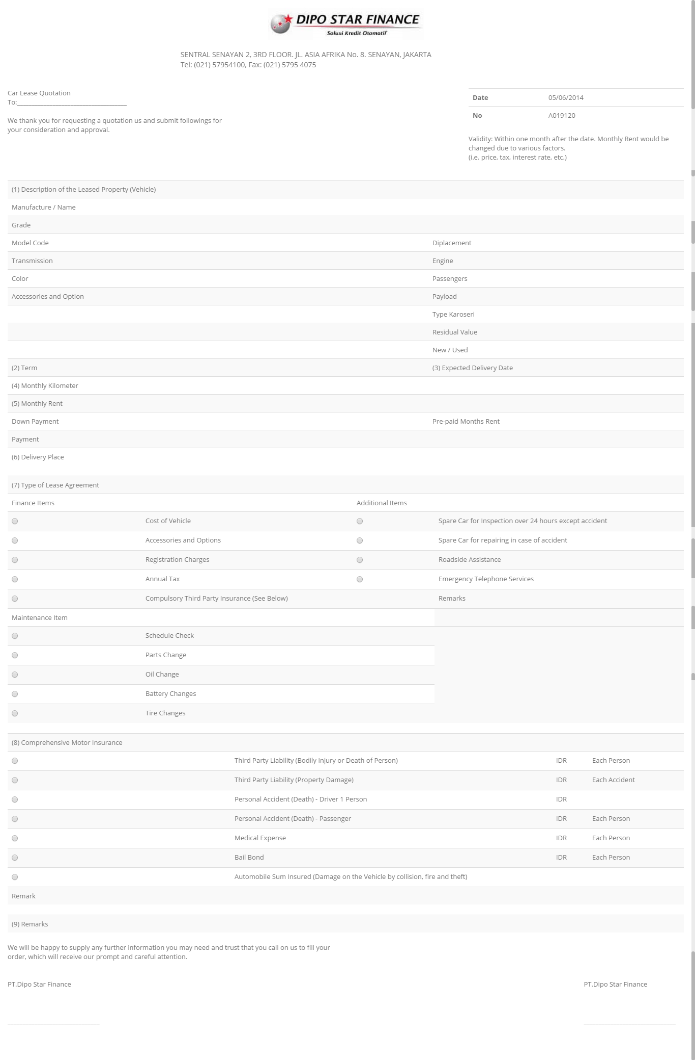

Image 35 – Screen of Preview and Print Operating Lease Quotation Screen

* + 1. **Screen features**

|  |  |
| --- | --- |
| **Features** | **Description** |
| [Filter and sort] | To perform data filtering and data sorting of calculation records. |
| [Create new] | To create new operating lease quotation by entry data on create new form. |
| [Save as draft] or [Set to draft] | To save a quotation as a draft. |
| [Submit] | To submit a quotation record as a final. |
| [Save changes] | To update of changes when editing operating lease quotation record. |
| [View detail] | To inspect a detail operating lease quotation records by opens a view detail form. |
| [Edit] | To update of operating lease quotation record. |
| [Validate] | To validate of operating lease quotation. |
| [Preview and Print] | To preview and print the report. |

* + 1. **Data structure**

|  |  |  |  |  |
| --- | --- | --- | --- | --- |
| **Field** | **Data Type** | **Data Length** | **Format** | **Mandatory** |
| **Quotation Identity** | | | | |
| OPL Calculation Number | Text | 50 | N/A | *Yes* |
| OPL Proposal Number | Text | 50 | N/A | *Yes* |
| OPL Quotation Number | Text | 50 | N/A | *Yes* |
| OPL Quotation Date | Date | N/A | mm-yyyy | *Yes* |
| **Product Basic Information** | | | | |
| Product Registration Code | Text | 50 | N/A | *Yes* |
| Product Type | Text | 100 | N/A | *Yes* |
| Product Category | Text | 50 | N/A | *Yes* |
| Product Brand Code | Text | 50 | N/A | *Yes* |
| Product Brand Name | Text | 100 | N/A | *Yes* |
| Product Model Code | Text | 100 | N/A | *Yes* |
| Product Model Name | Text | 100 | N/A | *Yes* |
| Product Model Type | Text | 100 | N/A | *Yes* |
| Product Model Year | Date | N/A | mm-yyyy | *Yes* |
| Transmission | Text | 100 | N/A | *Yes* |
| Fuel Type | Text | 100 | N/A | *Yes* |
| Displacement (cc) | Text | 100 | N/A | *Yes* |
| **Quotation Information** | | | | |
| Customer Code | Text | 10 | N/A | *Yes* |
| Customer Name | Text | 100 | N/A | *Yes* |
| Valid Until | Date | N/A | mm-dd-yyyy | *No* |
| Start Period Plan | Date | N/A | mm-dd-yyyy | *No* |
| End Period Plan | Date | N/A | mm-dd-yyyy | *No* |
| Lease Period Plan | Number | N/A | N/A | *No* |
| Terms | Text | 200 | N/A | *No* |
| Expected Delivery Date | Date | N/A | mm-dd-yyyy | *No* |
| Delivery Place | Text | 100 | N/A | *No* |
| Monthly Rents | Decimal | 18,3 | ###,###,###.## | *No* |
| Down Payment | Decimal | 18,3 | ###,###,###.## | *No* |
| Pre-Paid Month Rent | Decimal | 18,3 | ###,###,###.## | *No* |
| Payment Amount | Decimal | 18,3 | ###,###,###.## | *No* |
| Tax Amount | Decimal | 18,3 | ###,###,###.## | *No* |
| Additional Items | Text | 200 | N/A | *No* |
| Remarks | Text | 200 | N/A | *No* |
| **Audit Rail** | | | | |
| Create By | Text | 100 | N/A | *Yes* |
| Create Date | Date time | N/A | mm-dd-yyyy:hh-mm-ss | *No* |
| Last Modified By | Text | 100 | N/A | *Yes* |
| Last Modified | Date time | N/A | mm-dd-yyyy:hh-mm-ss | *No* |
| **Status Management** | | | | |
| Is Deleted | Yes/No | N/A | N/A | *Yes* |
| Is Draft | Yes/No | N/A | N/A | *Yes* |
| Is Submitted | Yes/No | N/A | N/A | *Yes* |
| Is Valid | Yes/No | N/A | N/A | *Yes* |

* 1. Agreement Information Inquiry
     1. **Use case**

The figure below is summarizing who uses features of function, and what they can do with it.

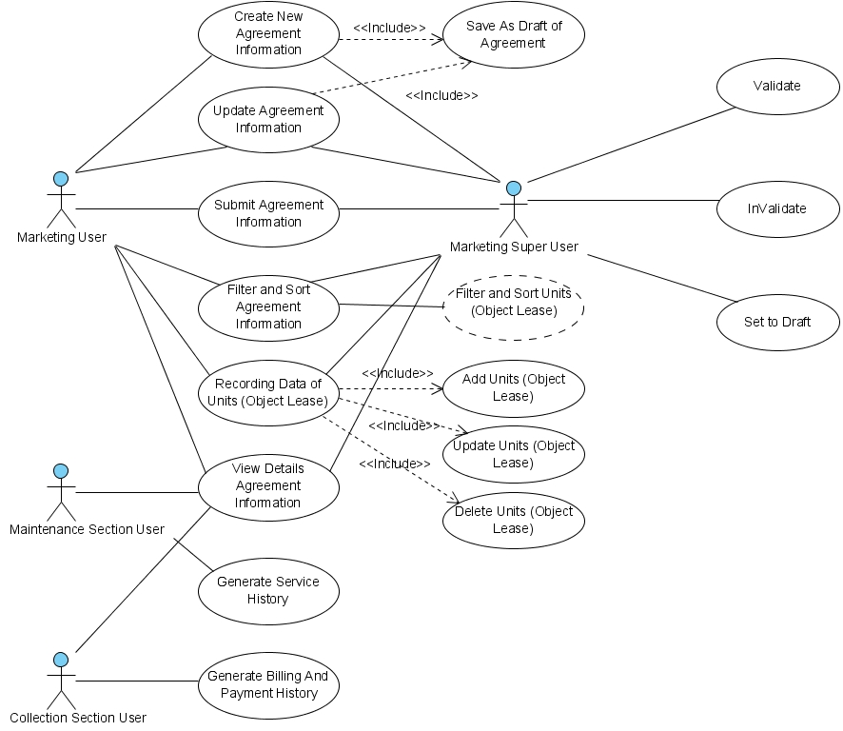

Figure 17 – Use case diagram of Agreement Information Inquiry

* + 1. **Operations and scenarios**

The figure below is describing operations or steps performed in a function interact with people (flow of work between actors and the system).

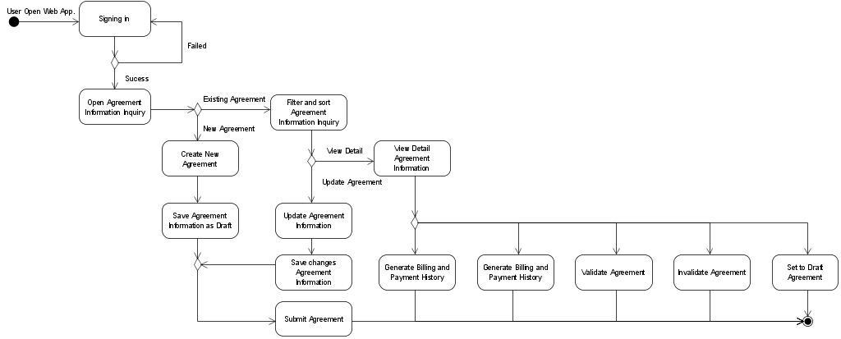

Figure 18 – Activity diagram of Agreement Information Inquiry

|  |  |  |  |
| --- | --- | --- | --- |
| **No.** | **Steps/ Operations** | **Actor/ People** | **Scenario** |
| 1 | Signing in | Marketing user, Marketing super user | * Actor fills out sign in form by inputting user name and password. * Actor clicks [sign in] button. System will check the account of user; if user account is already registered user will enter into the system. If doesn’t user can return the step. |
| 2. | Open agreement information inquiry module | Marketing user, Marketing super user | * After login, actor can open agreement information inquiry module on the menu of system. After that, the screen will be open. * Once it is open, agreement information list will be shown and existing data will be displayed. |
| 3. | Create new agreement information inquiry | Marketing user, Marketing super user | * If list of agreement information screen opens, actor can click [Create] button to create new data and after that agreement screen will be open. Once it open, actor can specify quotation number as reference for data input. * To specify the quotation, click […] button at quotation number, after that look-up window will be shown. These windows have features to search and select the calculation. At least one quotation must be selected. * Once it done, actor can fill out other information on each field. The mandatory fields cannot be blank. |
| 4. | Save operating lease agreement as draft | Marketing user, Marketing super user | * After filling out the fields, actor can click [Save as draft] button, if want to make a records as **draft**. * After that, system will proceed to store a data into database and will automatically check a validity of data (such as; data type, mandatory data, and data length) * If done, actor can click [Back] button to return to the list of agreement, then agreement data will be displayed. |
| 5 | Submit operating lease agreement record | Marketing user, Marketing super user | * Once data is saved and data has been confirmed, actor can submit the record by click [Submit] button. * After that system will set an agreement record as **submitted (or not draft)**. * If done, actor can click [Back] button to return to the list of agreement. |
| 6. | Update operating lease agreement records | Marketing user, Marketing super user | * On the list of agreement screen actor can click [Edit] button to update the record by editing data on the edit screen. * If the agreement still **draft**, *user* can click [Edit] button on the right side of the records on list of agreement screen. * If the agreement records already **submit** and the status is **valid**, *marketing user* cannot click [edit] button to open edit agreement screen. * If edit screen opens, actor can edit a record by inputting a data on each of the fields. The mandatory fields cannot be blank. |
| 7. | Filter and sort operating lease agreement records | Marketing user, Marketing super user | * Actor can filter and sort the record based on columns where displayed on the list. * To filter the records, actor can enter keywords into the filter fields. If matched data founds, the result will be displayed on the list. If doesn’t, the list will be empty. * To sort the records, actor can click header of column on the list table. After that the records will be sorted by ascending or descending, alternately. * Upon select [Record number filter] drop down list, actor can filter a record number to display on the list. At least only one item can be selected. |
| 8. | View detail operating lease agreement record | Marketing user, Marketing super user | * On the list of agreement actor can view detail agreement information on the view detail screen. * To open view detail screen, actor can click [View detail] button, after that system will display a detail of agreement. On this screen, actor cannot do anything to edit of data. Only viewing the record. * There are 2 conditions when view detail screen opens:  1. If the agreement status is still **draft** or already **valid**, [Validate] button and [set to draft] button will be disappeared. 2. If the agreement status was **submitted,** [Validate] button and [Set to draft] button will be shown.  * If done, actor can click back button to return to the list. |
| 9. | Validate Operating lease agreement | Marketing super user | * To do this process, actor should open view detail screen by clicking [View detail] button on the list. Once view detail screen opens, actor can change the status by clicking [validate] button. If quotation is already confirmed. After status changes to **valid**, actor cannot rollback the status to **submitted** or **draft**. * After that, system will proceed automatically to change the status, and actor can click [Back] button to return to the list. |
| 10. | Invalidate Operating lease agreement | Marketing super user | * In this feature (for the worst case), if quotation were made inoperative/ not applicable, actor can change the status from **valid** to **not valid**. * To do this process, actor should open view detail screen by clicking [View detail] button on the list. Once view detail screen opens, actor can change the status by clicking [Invalidate] button. * After that, system will proceed automatically to change the status, and actor can click [Back] button to return to the list. |
| 11. | Generate Service History | Maintenance Section user | * Once agreement already validate, user can generate service schedule based on maintenance condition and quantity of units on the agreement. The schedule will be generated base on ach of units as many as number of lease period with the status of Service History is Draft. |
| 12. | Generate Billing Payment History | Collection Section user | * Once agreement already validate, user can generate billing payment schedule base on payment condition on the agreement. The payment schedule will be generated base on ach of units as many as number of lease period with the status of Service History is Draft. |

* + 1. **Status management and roles**

The figure below is describing a role matrix (including relation with Status) of actor that already identified in a function.

|  |  |  |  |  |  |  |  |
| --- | --- | --- | --- | --- | --- | --- | --- |
| **Role of Actor** | **Filter and sort** | **Save as draft** | **Save changes**  **(draft)** | **Save changes**  **(submitted)** | **Submit** | **Validate** | **Preview & print** |
| Marketing super user | Yes | Yes | Yes | Yes | Yes | Yes | Yes |
| Marketing user | Yes | Yes | Yes | No | Yes | No | Yes |

The figure below is describing transition of Status that performed when people interact in a function. In this features, validation (validate and invalidate) process triggered on the operating lease agreement module. If the quotation already validate, so the status of operating lease agreement will be valid too, and vice versa.



Figure 19 – Status diagram of Operating Lease Agreement

* + 1. **Sitemap design**

Describe a web page that lists the pages on a web site to actors. Usually sitemap organized in hierarchical style.

Figure 20 – Sitemap design of Operating lease agreement

* + 1. **Screen design**
       1. **List of agreement information inquiry**

This screen is designed to display a list of operating lease agreement. On this list actor can filter and sort a records. And also, actor can open another screen to create new quotation record, update quotation record, and view detail quotation record.

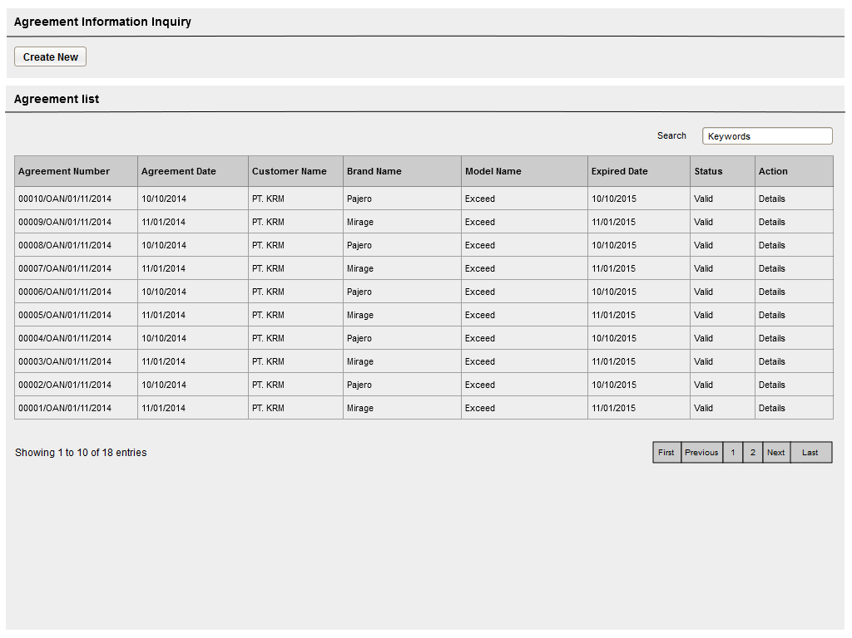

Data paging information

To open paging the records

To create new records

To filter records

To filter a number of record filter button

Displaying list

To open edit or view detail records

Image 36 – Screen of Agreement Information Inquiry List

* + - 1. **Create new agreement**

This screen is designed to create new agreement record. After filling out necessary data on the screen, actor can store a data into the system by clicking the action button.

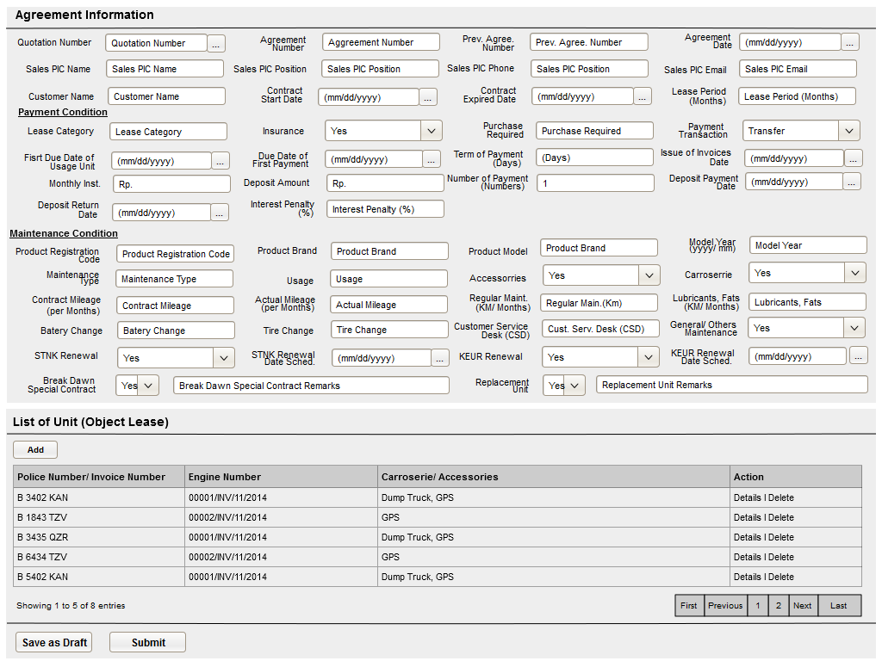

To open view detail and delete a records

To add new records

Data paging information

To open paging the records

To save and navigate the quotation data

To entry a quotation data

Image 37 – Screen of Agreement Information Inquiry List

* + - 1. **Update agreement information**

This screen is designed to update agreement quotation. After changes some data on the screen, actor can store a data into the system by click the action button.



To open view detail and delete a records

To add new records

Data paging information

To open paging the records

To save and navigate the quotation data

To entry a quotation data

Image 38 – Screen of Update Agreement Information

* + - 1. **View detail agreement**

This screen is designed to view detail agreement information. On this screen actor can change status of a operating lease quotation by clicking action button.



To open view detail and delete a records

To add new records

Data paging information

To open paging the records

To save and navigate the quotation data

To entry a quotation data

Image 39 – Screen of Details Agreement Information

* + 1. **Screen features**

|  |  |
| --- | --- |
| **Features** | **Description** |
| [Filter and sort] | To perform data filtering and data sorting of calculation records. |
| [Create new] | To create new operating lease quotation by entry data on create new form. |
| [Save as draft] or [Set to draft] | To save a quotation as a draft. |
| [Submit] | To submit a quotation record as a final. |
| [Save changes] | To update of changes when editing operating lease quotation record. |
| [View detail] | To inspect a detail operating lease quotation records by opens a view detail form. |
| [Edit] | To update of operating lease quotation record. |
| [Validate] | To validate of operating lease quotation. |
| [Preview and Print] | To preview and print the report. |

* + 1. **Data structure**

|  |  |  |  |  |
| --- | --- | --- | --- | --- |
| **Field** | **Data Type** | **Data Length** | **Format** | **Mandatory** |
| **Agreement Identity** | | | | |
| IdOPLAgreement | Numeric | N/A | N/A | *Yes* |
| **PIC Information** | | | | |
| PICFullName | Text | 200 | N/A | *No* |
| PICPositionName | Text | 50 | N/A | *No* |
| PICEmailAddress | Text | 50 | N/A | *No* |
| PICTelephone | Text | 50 | N/A | *No* |
| **Agreement Information** | | | | |
| CustomerCode | Text | 10 | N/A | *No* |
| AgreementNumberReff | Text | 100 | N/A | *No* |
| CustomerCodeReff | Text | 10 | N/A | *No* |
| AgreementNumber | Text | 50 | N/A | *No* |
| AgreementDate | Date | N/A | mm/dd/yyyy | *No* |
| StartPeriodDate | Date | N/A | mm/dd/yyyy | *No* |
| EndPeriodDate | Date | N/A | mm/dd/yyyy | *No* |
| TerminateDate | Date | N/A | mm/dd/yyyy | *No* |
| LeaseCategory | Text | 100 | N/A | *No* |
| **Payment Condition** | | | | |
| IsInsurance | Yes/No | N/A | N/A | *No* |
| PurchaseAfterLease | Yes/No | N/A | N/A | *No* |
| PaymentTransactionType | Text | 100 | N/A | *No* |
| FDueDateUsage | Date | N/A | mm/dd/yyyy | *No* |
| FDDatePayment | Date | N/A | mm/dd/yyyy | *No* |
| TermOfPayment | Numeric | N/A | N/A | *No* |
| DepositPaymentDate | Date | N/A | mm/dd/yyyy | *No* |
| DepositReturnDate | Date | N/A | mm/dd/yyyy | *No* |
| DepositAmount | Decimal | 18,0 | ###,###,###.## | *No* |
| NumberOfPayments | Decimal | 18,0 | ###,###,###.## | *No* |
| TotalMonthlyInstallment | Decimal | 18,0 | ###,###,###.## | *No* |
| TotalUnitQuantity | Decimal | 18,0 | ###,###,###.## | *No* |
| IssueInvoiceDate | Date | N/A | mm/dd/yyyy | *No* |
| InterestOfPenalty | Decimal | 18,3 | ###,###,###.## | *No* |
| Remarks | Text | 200 | N/A | *No* |
| **Audit Rail** | | | | |
| Create By | Text | 100 | N/A | *Yes* |
| Create Date | Date time | N/A | mm-dd-yyyy:hh-mm-ss | *No* |
| Last Modified By | Text | 100 | N/A | *Yes* |
| Last Modified | Date time | N/A | mm-dd-yyyy:hh-mm-ss | *No* |
| **Status Management** | | | | |
| Is Deleted | Yes/No | N/A | N/A | *Yes* |
| Is Draft | Yes/No | N/A | N/A | *Yes* |
| Is Submitted | Yes/No | N/A | N/A | *Yes* |
| Is Valid | Yes/No | N/A | N/A | *Yes* |

1. Appendix
   1. Use Case Terminology

|  |
| --- |
| ***What is the use case?***   1. ***A use case is*** *a written description of how users will perform tasks on your website.  It outlines, from a user’s point of view, a system’s behavior as it responds to a request. Each use case is represented as a sequence of simple steps, beginning with a user's goal and ending when that goal is fulfilled. (*[*http://www.usability.gov/how-to-and-tools/methods/use-cases.html*](http://www.usability.gov/how-to-and-tools/methods/use-cases.html)*)* 2. ***A use case is*** *a list of steps, typically defining interactions between a role and a system. (*[*http://en.wikipedia.org/wiki/Use_case*](http://en.wikipedia.org/wiki/Use_case)*)* 3. ***A use case is*** *a formal way of representing how a business interacts with its environment. it summarized into a single picture.* ([*http://romisatriawahono.net/lecture/sad/romi-sad-05-implementation-march2014.pptx*](http://romisatriawahono.net/lecture/sad/romi-sad-05-implementation-march2014.pptx)*)*   ***What are Benefits of use cases?***   1. ***Use cases*** *add value because they help explain how the system should behave and in the process, they also help brainstorm what could go wrong.  They provide a list of goals and this list can be used to establish the cost and complexity of the system. Project teams can then negotiate which functions become*[*requirements*](http://www.usability.gov/how-to-and-tools/methods/requirements.html)*and are built.*     *(*[*http://www.usability.gov/how-to-and-tools/methods/use-cases.html*](http://www.usability.gov/how-to-and-tools/methods/use-cases.html)*)*   1. *With the help of use case diagram, you can discuss and communicate:*  * *The scenarios in which your system or application interacts with people, organizations, or external systems.* * *The goals that it helps those actors achieve.* * *The scope of your system.*   *(*[*http://msdn.microsoft.com/en-us/library/dd409432.aspx*](http://msdn.microsoft.com/en-us/library/dd409432.aspx)*)* |

* 1. Calculation Formula

|  |
| --- |
| **=> Calculation of Refinance:**   1. Calculation formula    * **Net Sales**   ([Sales Price] * [Quantity]) - [Commission] - [Other Expense0,1,2,3]  ----------------------------------------------------------------------------------------------------------------------   * **Profit Amount**   [Net Sales] -[Residual Value]    **=> Calculation of Operating Lease:**   1. Step2 - Financial Condition:    * Prime Rate Effective   [Borrowing Rate Effective] +[Spread Rate Efective]   * Rate Flat   **(PMT(Rate, Nper, PV, FV, [type]) * -1 *Nper) - 1**  Rate = Effective Rate/12  Nper= Tenor Period  PV= Present Value (by default = 1)  FV= Future Value (by default = 0)  [type]= In advance; in arrier     1. Step3 - Maintenance Cost    * Sum Up Maintenance Cost Condition      1. Step4 - Insurance Cost    * Sum Up Insurance Cost Condition      1. Step5 - Operating Lease Result:    * Calculate Product Price   [Sum Up (Total Product Price + Accessories Price + Carroserie Price)] *[Unit Quantity]     * Calculate Maintenance Cost   [Sum Up Maintenance Cost] * [Lease Period Plan]*[Unit Quantity]     * Calculate Insurance Cost   [Sum Up Insurance Condition Cost]*[Lease Period Plan]*[Unit Quantity]     * Residual Value   [RV Rate] * [Product Price]*[Unit Quantity]     * STNK & KEUR Renewal Cost   [STNK Renewal Cost] + [KEUR Renewal Cost]*[Unit Quantity]     * Replacement Unit Cost   ([Replacement Unit]*[Lease Period Plan]*[Unit Quantity]) + ([KEUR Renewal Cost]*[Lease Period Plan]*[Unit Quantity])     * Mediator Fee Cost   ([Mediator Fee Cost]*[Unit Quantity])     * Mobilization Cost   ([Mobilization Cost]*[Unit Quantity])     * Demobilization Cost   ([Demobilization Cost]*[Unit Quantity])     * Insurance Cost   [Gross Premium] - [Commission]     * Interest Cost   PMT(([Borrowing Rate Eff.]/12),[Lease Period Plan],- (Total Product Price + Accessories Price + Carroserie Price),0,[payment type])*[Lease Period Plan]- (Total Product Price + Accessories Price + Carroserie Price)     * Depreciations   (Total Product Price + Accessories Price + Carroserie Price) - ((Total Product Price + Accessories Price + Carroserie Price) * [RV Rate])     * Interest Cost for TOP   [Term of Payments] * (Total Product Price + Accessories Price + Carroserie Price) * (Borrowing Rate Flat/360)     * Interest Cost for Payment Before BAST   [Interest Cost DP Unit] + [Interest Cost Payment Settlement Unit] + [Interest Cost DP Accessories] + [Interest Cost Payment Settlement Accessories] + [Interest Cost DP Carroserrie] + [Interest Cost Payment Settlement Carroserrie]   * Interest Cost DP Unit   [Total Product Price] * [DP Percent To BAST] * [DP Period to BAST] * (Borrowing Rate Flat/ 360)   * Interest Cost Payment Settlement Unit   [Total Product Price] * [PS Percent To BAST] * [Payment Settlement Period to BAST] * (Borrowing Rate Flat/ 360)   * Interest Cost DP Accessories   [Total Product Price]* [DP Percent To BAST] * [DP Period to BAST] * (Borrowing Rate Flat/ 360)   * Interest Cost Payment Settlement Accessories   [Accessories Price]* [PS Percent To BAST] * [Payment Settlement Period to BAST] * (Borrowing Rate Flat/ 360)   * Interest Cost DP Carroserrie   [Carroserrie Price]* [DP Percent To BAST] * [DP Period to BAST] * (Borrowing Rate Flat/ 360)   * Interest Cost Payment Settlement Carroserrie   [Accessories Price]* [PS Percent To BAST] * [Payment Settlement Period to BAST] * (Borrowing Rate Flat/ 360)   * Monthly Installment OPL   ([Ratio * TotalCost] + Total Cost )/ [Lease Period Plan]   * Insurance Income Cost   [Gross Premium] - [Commission]   * **Total Cost**   (Total Product Price + Accessories Price + Carroserie Price) - ResidualValueAmount + [STNK & KEUR Renewal Cost]+ [Maintenance Cost] + [Replacement Unit Cost] + [Insurance Cost] + [Mediator Fee Cost] + [ Mobilizations Cost] + [Demobilizations Cost] + [Interest Cost] + [Interest Cost for TOP] + [Interest Cost for Payment Before BAST]  ----------------------------------------------------------------------------------------------------------------------   * **Monthly Installment OPL**   ([Ratio * Total Cost ) + Total Cost/ [Lease Period Plan]   * Interest Income   (Total Product Price + Accessories Price + Carroserie Price) * [Spread Rate Flat] * ([Lease Period Plan]/12)   * Net Income LF   [Interest Cost] + [Interest Income] + (Total Product Price + Accessories Price + Carroserie Price) + [Admin Fee] + ([Rate Insurance Income] * [Insurance Gross Premium])  ----------------------------------------------------------------------------------------------------------------------   * **Total Profit**   [Monthly Installment] * [Lease Period Plan] |